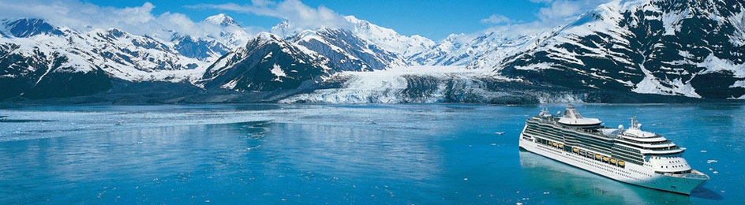

Join your hosts, Tom and Michelle Becker, as we explore the breathtaking beauty of Alaska!

August 29 – September 5, 2014
7-Night Alaska Sawyer Glacier Cruise
Royal Caribbean -- Rhapsody of the Seas
Departing from Seattle, Washington

You'll see legendary places, cruise past glacial fjords
and experience nature in a way you've never imagined before!

Pack Your Shorts -- Daytime Temperatures in Alaska During the Summer Range From 60°F-80°F!

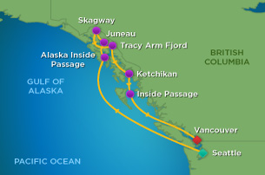

Your Northern Latitudes Entertainment Package Includes:

Tom and Michelle’s
John Denver Tribute Show
(We can’t imagine a more beautiful backdrop!)

PLUS
- TWO Additional Musical Performances by Tom and Michelle
- Pre-Cruise Meet & Greet Party
- Welcome Aboard Open Bar Happy Hour
- Latitude Trop Rocks the Glacier Party
- Reserved Group Dining
- And….. More Than We Have Space For Here!

From $ 1,098 Per Person
(Includes all Taxes and Port Charges. Airfare and Lodging Additional)

Cruise Website: www.latitudecruise.com
Latitude Website: www.latitudemusic.net
John Denver Tribute Website: www.johndenvertribute.net

Contact Karen Smith at Totally Travel: 910-392-1502 nights/weekends 910-397-7777

