

* ' BOOK647PAGE **168**

: ' 74 8

,..

.

•

STATE·OF SOUTH CAROLINA

COUNTY OF GEORGETOWN

**rIRBT SUPPLEMENTAL DECLARATION or**

COVENANTS, CONDITIONS AND '-", RESTRICTIONS FOR THE TRADitibN ffl' ; ;

I.

**WILLBROOK PLANTATION**

···; :r-- • -i

-i

This First Supplemental Declaration is m_ade as of thd 2:!f!# a fl;:_..,,

... UI :o:_r=

of August, 1995, by **CBNTBX REAL** ESTATE CORPORATION, (hereinaf-1teffe>::S8

r":i: - r.,

called the **"Deolarant").**

WIT NE s s ETH:

·· *t:? v,_*

*(_._')* ...;i.,

*n* Ul CJ1

WH REAS, **CBNTBX REAL ESTATE**·CORPORATION, II **Nevada Corporation,**



•

did made and declare that certain Declaration of covenants, Conditions and Restriction for Phase I, The Tradition at Willbrook Plantation (the **"Deolaration")** dated December 29, 1994, recorded Fe ruary 23, 1995 in Deed Book 616, at page 192, and rerecorded May 28, 1995 in Deed Book 620 at page 273, office of the R.M.C. for Georgetown County, South Carolina; and

·wHEREAS, Article X, Section 2 of said Declaration provides that the Declaration may be amended by consent of two-thirds (2/3) of the lot owners; and

WHEREAS, Declarant is still the owner of all lots subject to said Declaration and Declarant wishes to supplement and amend the Declaration as stated herein below.

NOW, THEREFORE, the Declarant hereby wishes to acknowledge and confirm that_all properties subject to the Declaration are also subject to the Declaration and creation of wetlands· Natural Area Preserve recorded in Deed Book 505, at page 142, office of the R,M.C. for Georgetown County, South Carolina,· and as such any lot that· is affected by wetlands or a wetlands buffer area is hereby restricted so that no clearing, filling, excavation or construction

-1-

COUrfrt **PMr.Pi** ,





BO□K647rAG**1**E**69**

. activity, no; cultivation of gardens or lawns shall be **allowed**



**within** the wetland areas, except for the following:

**(a)**

Removal of shrubs and trees no greater than two (2) inches in diameter (measured at breast-height) to create a pathway, which shall not exceed three (3) feet in width;

Removal of dead or dying trees determined by a registered landscape architect, registered forester, or Georgetown County Arborist_to be diseased or a hazard, and then only with the permission of the then owner of the property and the applicable Homeowners Association upon which the dead or dying tree is located; and

Planting or repianting of native shrubbery and trees so long as no other term of this Declaration .is violated to enable such planting or replanting

FURTHER, the Declarant.wishes to clarify that Phase I as noted in the title to the Declaration is intended to reference he first phase of constructi_on in The .Tradition at Willbrook Plantation, and that the first phase of construction is actually titled as Phase_2,

•

Parcel 1 as noted in Exhibit "A" to the Declaration. Any reference

'::_ *:•*

0

to Phase I ihthe Declaration shall be deemed a reference to Phase

* 2, Parcel No. 1.

WITNESS our hand and **aoala** the day and year first above written.

 

•

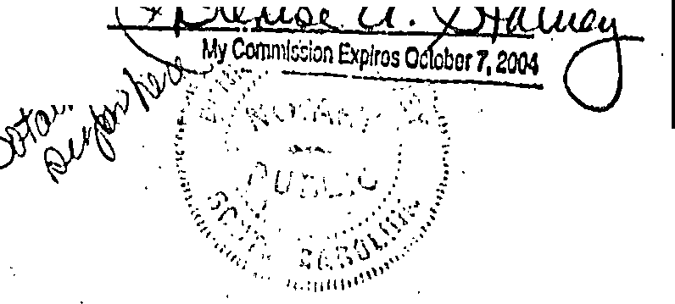

r:)/ef') r

Witne.sses:

*'. c_{:Y yJ_G::-:f-"1=l =-,cJ-, ;.!..*

-2-

I

- . . ' *:* •

..... ------..·-------- ·--· - ·_ I ..--

* 

•

|  |  |  |  |  |
| --- | --- | --- | --- | --- |
| .. |  | ,. |  | |
|  |  | .l, | . |
| '  I |  | STATE OF SOUTH CAROLINA  PROBATE  COUNTY OF  PERSONALLY appeared before me the undersigned witness and made oath that he/she was present and saw.the within named **CEN'l'BX**  **RBAL !STAT!** CORPORATION by )o119 U.C·lbrolcl its &r1tm)\er::  sign, seal, and as the corporate act and deed, deliver the foregoing First Supplemental Declaration of Covenants, Conditions and Restrictions for The Tradition at Willbrook Plantation; and that he/she with the undersigned·notary witnessed the execution thereof,  f: \l'SfRS\ANN\STEVEll'S\CtNTEX.SUP (08,21,95)  -3- | |  |
| •I |  |

'

••

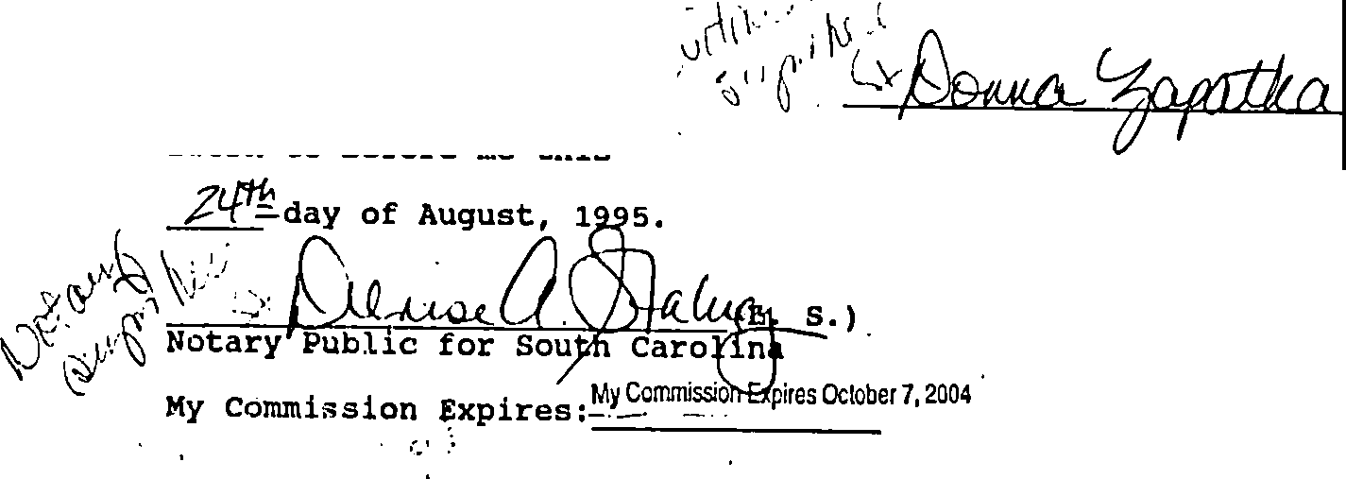

•

r::c..,..~~.. •· .....~~

f--- ' '

:·1



.,

 ,.**.i\ ··.: - i.** ,. , : ·



,;. .

i

..,

*I*' *.*

1 •

I

I

I

# '.':,,. **,o**

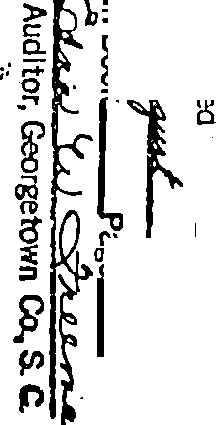

**5'**

8

***::1***

**vi**

...

**n,**

f **9**

... I»

p

*rl? -:.:·*

S'

**U1**

-if:,.-,,

:,-..

**Gr:="'l,** *·:.-: .*..

**.;.J**

i

"**C.**"**JI**

;J::i-

* } .*;*.*:*.*:*.*:*.*.*.*·* **-, 2::**



**w**

**L7r**

***Y,-*** :?-

**w ::r..**

**U1 er,**

8

-;_fl"

*?*

¥ -t)

f

*F*

-Jr .

- **f:**

***rr***

***Ji***

·

£

-f

- -·--·

c

,.

1• .

_.-. •,

,,

•

