•



9038

aoor.654,aGE **338**

STATE OF SOUTH CAROLINA

COUNTY OF GEORGETOWN

SECOND SUPPLEMENT TO DECLARATION OF COVENANTS, CONDITIONS, AND RESTRICTIONS FOR THE TRADITION AT WILLBROOK PLANTATION-

to the Declaration **of ccivenants,**

·i'

**This** . Second Supplement

conditions, and Restrictions for The Tradition t Willbrook

Plantation is made this *.:l.511'* day of  **r,.fol!r-** , 1995, by Centex Real Estate Corporation, **a** corporation organized and existing under

the laws of the State of Nevada, but authorized to do business in South Carolina, (hereinafter referred to as "Declarant").

•

**W** I T **N E s s E T U**

WHEREAS, Declarant has previously imposed upon the property described therein ·a certain Declaration of Covenants, Conditions, and Restrictions (hereinafter "Restrictions") for The Tradition At Willbrook Plantation. Those Restrictions are dated December 29, 1994, recorded in Deed Book 616, at page 192 and rerecorded in Deed Book 620, at page 273, Office of the RMC for Georgetown County, south Carolina: and

WHEREAS, Declarant desires by this Amendment to add and subject to said Declaration pursuant to Article V of said Declaration, the property described in Exhibit "A" which shall be held, sold and conveyed subject to the easements, restrictions, covenants, and conditions set forth in. said Declaration which are for the purpose of protecting the value and desirability of nd. which shall run with the real property described herein, and which

•

shall be binding on all parties having any right, title orfl}-,nterest

g · ,(> 0

in the described properties . _or part thereof, theit he<g"s,

successors, successors-in-title, and assigns, and shallI,ji

u t

..-,r-

-

the benefit of each owner thereof.

"Tl;, "'tl r-

. *c*l•*,,*,

r-C

:,:,:;. 11'--f'TI

*4--* - */'t:,l=* -, *rH-.* •i . ca )>

 4 -1'iS1!; -4!f

:-: N 3:

V> _, C/l

n

..

, , ..-......

•



* _L_



. ·aoor.654rAGE 339

NOW THEREFORE, for and in consideration of the premises recited above, Declarant her by covenants and agrees as follows:

1, The property described in Exhibit "A" which is attached hereto.and incorporated by reference herein shall become and is hereby declared to be property subject to· the Declaration of Covenan s, Conditions, and· Restrictions 'for The Tradition At

.Willbrook Plantation dated December 29, 1994, and recorded in the Deed Book 616, at page 192, Office of the RMC for Georgetown County and rerecorded in Deed Book 620, at pag·e 192, said property being annexed pursuant t.o the provisions of Article V of said Declaration,

•

2. It is hereby agreed. that the aforesaid Decl ration of

covenants, conditions, and Restrictions for The Tradition At Willbrook Plantation dated December 29, 1994 shall be and the same is hereby ratified, confirmed and adopted in all respects, as amended, and all particulars as to those provisions expressly amended as set forth herein; and it is further agreed that this document shall, and does hereby constitute a second supplement to

**.the aforesaid** Declaration of Covenants, Conditions, and Restrictions for The Tradition at Willbrook Plantation with regard **to the matters** set forth herein,

3, **"Thia** Second supplement to the Declaration of Covenants, Conditions, and Restrictions for The Tradition At Willbrook Plantation shall be binding upon a d in re to the benefit of all **parti a** having any right, title or interest in the described **propertie•** or any part thereof, .their heirs; successors,

•

•ucc•••or••in•title, and a••ign•, and •hall inure to the benefit of

-------,-------------.:..... -'

------..,--;---------------,----- ------...- - -··----

•

•/;.;, - -::::=;=--··---•.;..·...;'·"'·· ·-.:..·_...:_.:..:_..;._.:_. _



**each** owner thereof,

IN WITNESS HEREOF, t_he undersigned Declarant has executed this Second Supplement to the Declaration of Covenant&, Conditions, and Restrictions for The Tradition At Willbrook Plantation this *;l.*

day of l"lt r , 1995.

**CBNTBX REAL BSTATB CORPORATION**

**By "".** _**-•**-**_*-'-*·*--1_***

Its:_._J..c..,.,.1...t.a....,......*l*.*....al.e.r...: _*

## ----'--Al!· 1

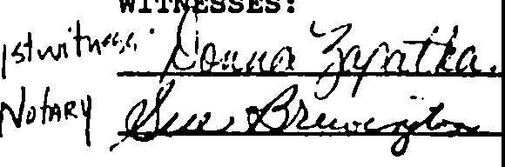

STATE OF SOUTH CAROLINA

couNTY oF Tue k"' ·

PROBATE

PERSONALLY appeared before me the undersigned witness and made oath that,(s)he,saw the within **cpNTEX REAL ESTATZ CORPORATION,** by.



. j

* ◄

1

I

·l

•

\)r1t1nl11 l)cw,lr, its, (C•t1h:u//,,_, sign, seal

and asl its corporate act and deed deliver the within second Supplement to the Declaration of Covenants, Conditions, and Restrictions and (s)he with the other witness witnessed the execution thereof and saw the corporate seal affixed thereto.

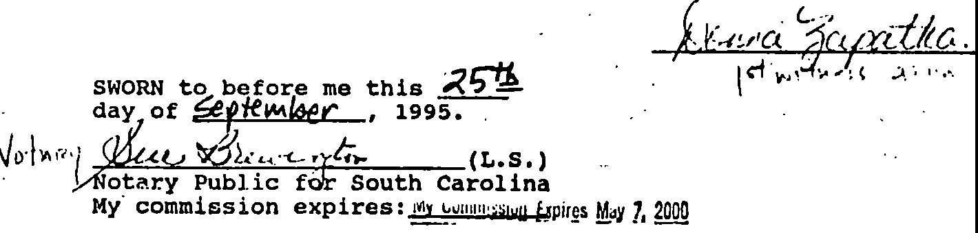•

•

Exhibit "A" •

ALL AND SINGULAR, all that certain piece, parcel or tract of land in Willbrook Plantation, Litchfield Beach, Georgetown County, South Carolina, described as Phase 8, of Parcel 1, of The Tradition Club Subdivision, containing 45 lots, all of which are more particularly shown and described on **a** plat of said property drawn by TRICO Envirometrics, Inc,; dated May 23, 1995 and recorded June 12, 1995, at Slide 173, at Page 2 in the office of the RMC f-or Georgetown County, South Carolina, reference to **aaid** plat being

*:* craved hereto•• formin9 a part and parcel hereof,

•

'.-



,_

....

..



.•..,

•

.. •

j

•I.·

- ----------------·-----·--·•·---

•

• • • •

-----•-·· - -.-----.-.....- ·-·----

',,.

*-f/D.OOf&*

### FILED

f:f.TTY L. WILLIAMS

CCCP& GS

### 950Cl 11 PH 3: 27

a•a• K• .k.•5.•4•: •,\"tJH--'i:;,ss:c•

· *£Ja~~a.~~J, i*-*J*-*,*"*:*'*.*"*U*·-*­*}

*tP.0* .,&-/.*1533*

1

I

*,SC '1S«* _

*(·* f: ..._

*!Irr.JI(,:"* ,. I c:

-' "fr'

* o/ *-:*

*N ..* _,., ..,,_t..,(L .._

'J• •!I ·

# *1I*

:,

*·*·*•*•*i"* ***C\l***

,; '

1L h

·'·••

"**c:**■"**:,**

....

ca

""

lt'::t

.***·u***..***:***:***,***·

-0 ,

!'"--•:

.,aday 01

# *- ---u l\n.,99r*

*i8:78J*-

*:OHrr-1*

**Auditor,** Georgetown Co., S. C.

·1