* Boo 673PaGE **225**

STATE OF SO'lJ'l'.H CAROLINA

COUNTY OF GEORGETOWN

THIRD SUPPLEMENT TO DECLARATION OF COVENANTS, CONDITIONS, AND RESTRICTIONS FOR THE TRADITION **AT**

·wiLLBROOK PLANTATION'

li

I

l

This Third· Suppletnent to. the Declaration of Covenants, condition , and Rer.;trictions for the. Tradition at Willbrook Plantation is m de this ....2:JJ1,day of Decetnber, 1995, by C ntex Real Esta e Corporation, **a** corporation organized and existing under the

laws of the Stat;e of Nevad.a, but authorized to do business in South

Car9lina, _(he einafter referred to as "Declarant").

**WI'l'NBSSE'l'H**

•

WHEREAS,· Declarant has previously imposed upon the property described ther in a certain Declaration of Covenants, Conditions, and Restrictions (hereinafter "Restrictions") for the Tradition At Willbrook Plantation. Those Restrictions are dated Decetnber 29, 1994, recorded in Deed Book 616, at page 192 and rerecorded in Deed Book 620,·at page 273, Office of the RMC for Georgetown county, South Carolina: and



WHEREAS, Declarant desires by this Amendment • to add and subject to s·aid Declaration pursuant to Article V of said Declaration, the property described in Exhibit "A" which shall be held, sold and c mveyed subject. to the easements, restrictions, co enants, .and conditions set.forth in said Declaration which are for tpe purpose of protecting the value and desirability of and which shall run with the real property described herein, and which

•

shall be binding on all parties having any right,. titl·e ord-i;iterest

.

Or: .I.O c:,

L

in the described rope•rti es or part thereof, theii**o**,<**c**; ec**en**;**,**-**.** s, ..**r**.**r**..;

I

the benefit of each owner thereof,

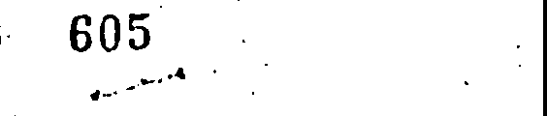

ij

l

l

.I

l •

j

> ('"')--1

successors,· successors-in-title, and assigns, and shall incur tcn-<"TJ

;; ::; : r=

oourtrt PARCEL , 4-;:4C8-I .tc

* u.Ju



c-, -,:, p. l'Tl

:x e1:=CJ

g

r

<I>>

r

:< (.,) .:r:'

epn **en** en

J

;_r------



1 {"

,:,.l ,

,.. •



NOW THEREFORE, for and in consideration of the premises recited above, Declarant hereby covenants and agrees as follows:

*:* I i-; The property described in Exhibit "A" which is attached .

* '

hereto and incorporated by reference herein shall become and is

* I hereby declared to be property subject to the Declaration of covenants, Conditions, and Restrictions for The Tradition At Willbrook Plantation dated December 29, 1994, and recorded in the Deed Book 616, at page 192, Office of the RMC for Georgetown County

and rerecorded· in Deed Book 620, at page 273, said property being

••

annexed pursuant to the provisions of Article V of said Declaration.

2. It is hereby agreed that the aforesaid Declaration of Covenants, Conditions, and Restrictions for the Tradition At Willbrook Plantation dated December 29, 1994 shall be and the same is hereby ratified, confirmed ahd adopted in all respects, as amended, and all particulars as to those provisions expressly amended as set forth herein; and it is further agreed _that this document shall, and does hereby constitute a third supplement to the aforesaid Declaration of Covenants, Conditions, and Restrictions for The Tradition at Willbrook Plantation with regard to the matters set forth herein.

J.. This Third Supplement to the Declaration of Covenants,

Conditions, and Restrictions for The _Tradition At Willbrook Plantation shall be binding upon and inure to the benefit of all parties having any right, title or interest in the described properties or any part thereof, their heirs, successors, successors-in-title, and assigns, and shall inure to the benefit of

.I

!

#### IIOOK673PAGE **227**

each owner thereof.

IN WITNESS HEREOF, the undersigned DEiclarant has executed this

second supplement to the Declaration of covenants, conditions, and **Restrictions for The Tra4ition At Willbrook Plantation** this ;;_7'fj **C,ay *ot_ kfc 4V:*** , **1995.-.**

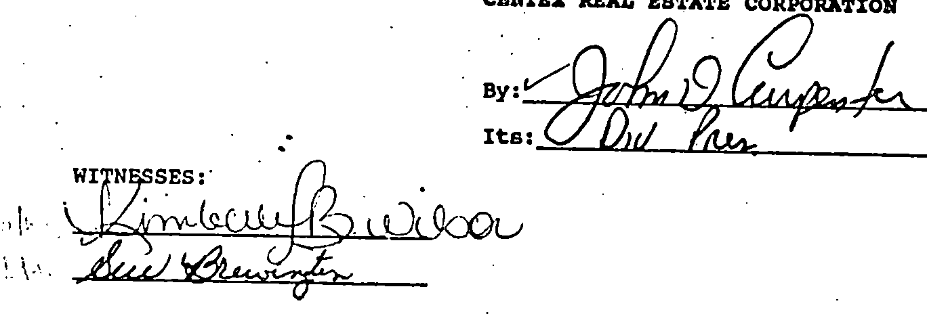

#### STATE OF SOUTH CAROLINA COUNTY OF HORRY

#### PROBATE

PERSONALLY appeared before me the undersigned witness and made oath that (s)he saw the within CENTEX REAL ESTATE CORPORATION, by



SWORN to before me this *J.J'b-*

day of· *Dtze\M,1Aac* , 1995

•

r•,),·.\;c.;: 1 *A«1*

' My commission **expires:**  cmmlss_lp!). µp!rcs !!aY *l,* 2000



...:!:'.·'.: _:i

*:*-: *:* ; ' ·.· '..*·:;*

• -·'•"'-

, Notary PublicfoSouth Carolina

(L.S.)

!

.

-, _>; t *_.:*

* 1 *:*.*.:*.

: .

its,.,,......-- -...,...,..,. ,--=--sign, seal and as its

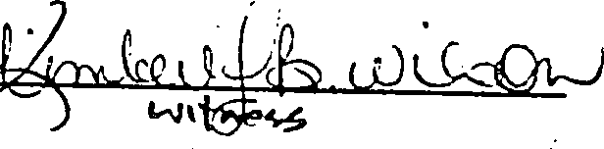corporate act and deed deliver the within Second Supplement to the Declaration of Covenants, Conditions, and Restrictions·and (s)he with the other witness witnessed the execution thereof and saw the corporate seal affixed thereto.

•





.... ..• ';. ..

• > • --·

' I

·1

.. '

\, . •



, I

### I Exhibit "A"

, I

! All and Singular, all that certain piece, parcel or tract of land in Willbrook Plantation, Litchfield Beach, Georgetown County, South Carolina, described as PHASE 4, PARCEL l of the Tradition Club Subdivision, containing 28 lots, all of which are more particularly shown and described on a plat of said property drawn by TRICO Envirometrics, Inc., dated November 1, 1995 and recorded November 21, 1995 at slide 185, at page l, office of the RMC for Georgetown County, South Carolina, reference to which is craved as

•

l forming **a** part and parcel hereof.

! •

### i

I

I

i

•

,- ,..

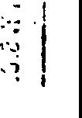·,,

1•·- r7.;.·.

I. ::- •

, . .,1 !I ..

I

q,oo

-------.-. t.:;;.;.i=.o e,c.;.

*R*

*Tnornpstm La.w rm* •

*If.JOI* ***tJ. oak* s-{-.** FILED

***m* B SC.** [?El TY L. **WILLIAMS**

CCCP & **GS**

**96JAtl 17 PH 2136**

(

,',

. _J,;

·.Ji.



"/}

. *:***1**

-. .:·.,·.'.!·..1 -•

:.::-•

;;.c

('C)

## fC7>

'ij...

*,r*

:1LU!"!..i: r .,, ..

C,rz.#/

uDDK t.ou s.c.

### iY\ *5*

*JCf*

- - t tJJ. o,,"r•

'I

# *f:*

r;:

i

::--

;

***'t.D***

c,.

""

..

*3J* k) r-·'

ti-- *P I*

*f­*

# *t*

i;·,··

I*i*.*'*

*(·*

... *,t,*

.•.•

*±:'.'\_,.,,,.,*..,..

P..0.19.!t

In 1c.

-r=w:;;"../

*Gt* ::11 **t** ,y,

Auditor, **Co,S. C.**

L.

i

!'

\ ..

I ;

## I..

j!

*I*

!

• • • •

?

r.

i_J'

*(*

*(*

- - ·*;__;;_.)*

*:_* - . ,:.,