

1. -'------ ---------------' -- .==i

•

r 5978 me -

f' Boor.698PAGE •• 22 g g,:

I!., Jf....i.. -s< c-,--ii

* + 0 c-,-<



STATE OF SOUTH CAROLINA ) FOURTH SUPPLEMENT TO DEC o c-:,r.,,

j

) OF COVENANTS, CONDITIONS, *;Jiu>,* ;:i;;

COUNTY OF GEORGETOWN ) RESTRICTIONS FOR THE TRADI Q!II **ji** G"lro

WILLBROOK PLANTATION

*:;'=* en

:< 0 )>

**This** Fourth Supplement to the Declaration of c vfI'aMs,

Conditions, and Restrictions for the Tradition at Willbrook

*1*

Plantation is made this

day of \#1]1 , 1996, by Centex

Real Estate Cprporation, a corporation organized and existing under the laws of the State of Nevada, but authorized to do business in South Carolina, (hereinafter referred to as 11Declarant11)

*,J* •

,f.-.·1

,..

L I

* I

1 •

!'

l.

f,.

**W** I T **N B S S** I **T H**

WHEREAS,·Declarant has previously imposed upon the property described therein a certain Declaration of covenants, Conditions, and Restrictions (hereinafter "Restrictions") for the Tradition At Willbrook Plantation. Those Restrictions are dated December 29, 1994, recorded in Deed Book 616, at page 192 and rerecorded in Deed Book 620, at page 273, Office of the RMC for Georgetown County, south Carolina; and

WHEREAS, beclarant desires by this Amendment to add and

subject to said Declaration pursuant to Article V of said

I '.

Declaration, the property described in Exhibit "A" which shall'.be held, sold and conveyed subject to the easements, restrictions, covenants, and conditions set forth in said Declaration which are for the purpose of protecting the value and desirabi:)..ity of and which shall run with the real property described herein, and which shall be binding on all parties having any right, title or interest in· the described properties or part thereof, their heirs, successors, successors-in-title, and assigns, and shall inur to

•

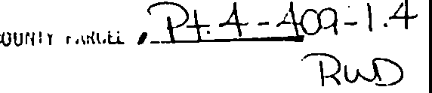

•. *I*

•

I

•  -------'-.·, .. .:.':,;:;; At;,,.·.t,.......:.. . .*.·:.,·..•,.":.*



.,,. .

•

·- ----·-··------- ·.



# Boor.698rAGE 23

the benefit of each owner thereof.

NOW THEREFORE, for and in consideration of the premises recited above, Declarant hereby covenants and agrees as follows:

1. The property described in Exhibit "A" which is attached

hereto and incorporated by reference herein shall become and is hereby declared to be propercy subject to the Declaration of Covenants, Conditions, and. Re.strictions for The Tradition At Willbrook Plantation ·d ted December 29, 1994, and recorded in the Deed Book 616, at page 192, Office of the RMC for Georgetown county and rerecorded in Deed Book 620, at page 273, said property being annexed pursuant to the provisions of Article V of said

•

* + Declaration.

1. It is hereby agreEid that the aforesaid Declaration of

Covenants, Conditions, arid Restrictions for the Tradition At

Willbrook Plantation dated December 29, 1994 shall be and the same is hereby ratified, confirmed and adopted in all respects, as amended, and all particulars as .to those provisions expressly amended as set forth herein1 and it is further agreed that this document shall, and does hereby constitute a fourth supplement to

the aforesaid Declar tion of covenants, conditions, and

Restrictions for The Tradition at Willbrook Plantation with regard to the matters set forth herein.

1. This Fourth Supplement to the Declaration of Covenants, Conditions, and Restrictions for The Tradition At Willbrook Plantation shall be binding upon and inure to the benefit of all. parties having any right, title or interest in the described properties or. any part thereof, their heirs, successors,

•



•

|  |  |  |
| --- | --- | --- |
|  | ·-• | |
|  |  |
| eoo 698rAGE ·- **24**  auccessors-in-title, arad assigns, and shall inure to the benefit **of**  **each** owner thereof,  IN WITNESS HEREOF, the_ undersigned Declarant has executed this Fourth'supplement to the Declaration of Covenants, Conditions, and Restrictions for The Tradition At Willbrook Plantation this *l t­*  day of r'\ - v\-t---' 1996,  \  **CB!l'l'BZ UAL BBTATB CORPORATIOH**  By:_ _b ,, ,--- --+{_  Its: -.,.;-c::.. .....;-{i._rJ-'V.....;'4'-----  l fW:ITN;ESS:ESi: f:t  STATE OF SOUTH CAROLINA )  ) PROBATE  COUNTY OF1:o-rJ...:e,-'tW )  PERSONALLY appeared before me the undersigned witness and made oath thaj);s)hd, saw the within **CEN'l'EZ REAL** ESTATB **CORPORATION,** by  *jp* u.9 *µc* rtQ.( its, <1,,pntro11er sign, seal and as its  corporate act and deed deliver the within Fourth Supplement to the Declaration of covenants, conditions, and Restrictions and (s)he with the other witness witnessed the execution thereof and saw the corporate seal affixed thereto.  w, 'f's .  ../. | |

•

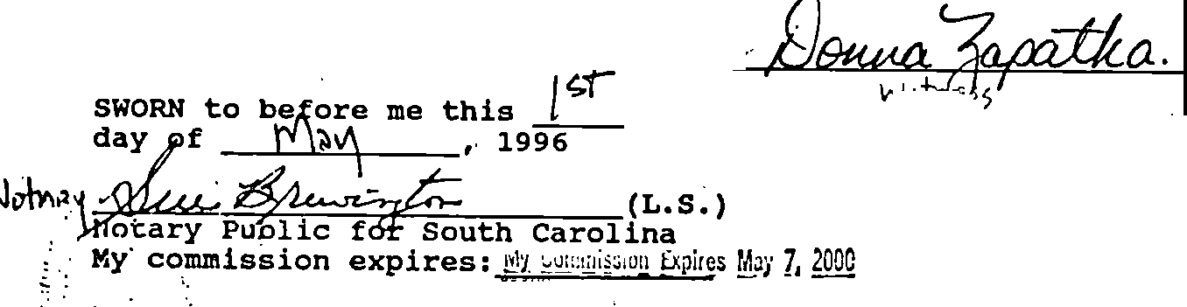•

* *.v*



i. ,. •

 . :. .. *_.;; ::.;,<.* ·'· •..(,.:.

•

800r.698r GE 25

# Exhibit "A"

All and Singular, all that certain piece, parcel or tract of land in Willbrook Plantation, Litchfield Beach, Georgetown County, South Carolina, -described as PHASE 7, PARCEL 1 of the Tradition Club Subdivision, containing· lots, all of which are more. particularly shown and described on a plat of.said property drawn by TRICO Envirometrics, Inc., dated ':!.,,clu \ , 19 and



*>;*

recorded e\'I 1, o ... J , 19jk at slide 19..2., at age _£_, office

of the RMC for Ge'drgetown County, south Carolina, reference **to**

•

which is craved aa forming a pah.and parcel hereof .

,,,

* 
* *::* .-.,

---":''·*-.*-*:-*

-• *·1•·' .*.. '·,

. '



,l'.

I'·

.....,  •

f,' ... •·· . . .

;::: ;.;.;._·-·'-'-'·. - ·= ·•-::.....·:.,.;•.·;·::.....·-"-·'..c..::11:·A.;...:• c...;··C--'-•*:,.....c*·*:* _..;_·..:.:.,•·•c.. c.·-'-·-'-:-·-'-'-•.·.:._·.,;._c_-· ·''--_-·=- =• ;-=-:;;-'- -.:: =·-·: *.. -- -..,>,.;* •..

.....•.. ·,,.,·, •

-

**BOOK698rAGE c26** *:--*.,:

\,. .·'•

' .

•

(,.

l

i'

*! :*

t-- i. [:

,1'.·

.

ff

•

.Jr)'··.f•-

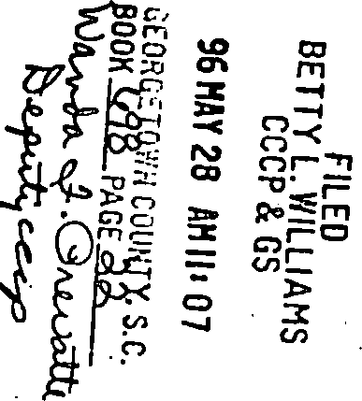f:'p *7·* J=

I

f

f

o=-- . ..J 0

cS -0 *c;t->*

*p*



•

t ;

