9479

" .), _•, ·-• .·.:. ..

BOOK716rm **162**

## STATE OF SOUTH CAROLINA COUNTY·OF GEORGETOWN

O>C>

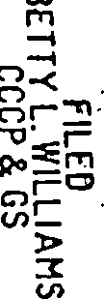00 O'I

,

or, *'°*

-0 \0

# GENERAL WARRANT E1!i

m-i l =M

:< 0

u, N

KNOW ALL MEN BY THESE PRESENTS, that 2728 HOLDING COR O TION,

A Nevada Corporation, formerly known as CENTEX REAL ESTATE CORPORATION, in the State aforesaid, in consideration of the sum of

* I

FIVE AND 00/100 ($5,00) Dollars to it paid by TRADITION AT

WILLBROOK PROPERTY OWNERS ASSO<;:IATION, INC. in"the State aforesaid

(receipt whereof is hereby acknowledged) have granted, bargained, sold and released, and by these presents do grant bargain, sell and release unto the said TRAJ?ITION AT WILLBROOK PROPERTY OWNERS ASSOCIATION, INC., its successors, heirs and assigns, the following described property, to-wit:

See attached Exhibit "A" for Legal Description.

DERIVATION: This is a portion of the property conveyed to the grantor • herein by deed of The Litchfield Company dated

. u. s25 1 1995, and recorded C\Llnqp:\ I , 1995 in Deed Book

*~~�.~~* at Page --3..13,

South Carolina,

. *b*

office of the RMC for Georgetown County,



•

## GRANTEE'S ADDRESS:

*ZJf o* W\;)11 t>Y\v , S1,1.dt *'3i;-o*

*-* ek11v-l -.tu ... 1 *":>l... 2-'l'f{)*

TOGETHER with all and singular, the Rights, Members, Hereditaments and Appurtenances to the said premises belonging, or in anywise incident or appertaining,

**TO. HAVE AND TO HOLD all and singular the premises before** : .,..

mentioned unto the said TRADITION AT WILLBROOK PROPERTY ·OWNERS ASSOCIATION, INC,, its successors, heirs and assigns, forever. ,·;."!

AND grantor does hereby bind itself and its Successors,. Heirs and Executors and Administrators, to warrant and forever defend all

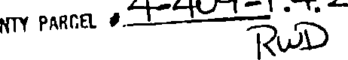

I

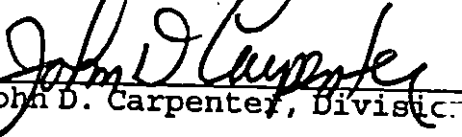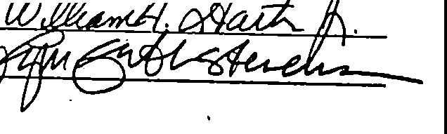·. •'.•· •·. .

•





....

·-.

BO□K716rAGE **163**

and singular the said·premises unto the said TRADITION AT WILLBROOK PROPERTY OWNERS ASSOCIATION, INC., and its Successors, Heirs and Assigns, against itself and its heirs and assigns, and all persons whomsoever lawfuliy claiming, or to claim the same, or any part thereof.

WITNESS the execution hereof by Grantor this *Z* d y of July, in the year_of our Lord One Thousand Nine Hundred and Ninety­ Six and in the two hundred and twenty-first year of the Sovereignty

and Independence of the United States of America.

2728 HOLDING CORPORATION,

A Nevada Corporation, (formerly known as Centex Real Estate Co ration).

* on President

I

SIGNED, "SEALED AND DELIVERED IN THE PRESENCE O:

\

·-•

BOoK7l6rm **164**

## STATE OF SOUTH CAROLINA COUNTY OF GEORGETOWN

## PROBATE

i

\·.l



1

:J

:1

·l

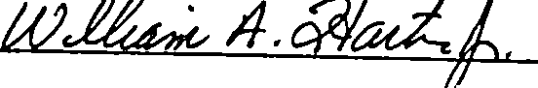

PERSONALLY appeared before me the undersigned witness who made oath that (s)he saw the within named 2728 Holding Corporation, a Nevada Corporation, by John D. Carpenter, its Division President, sign, seal and as its act and deed deliver the within written Deed and that (s)he with the other witness whose signature appears above witnessed the execution thereof.

*fl*

· Sworn to before me this day of July, 1996.

Carol na My Commission Expires: *11-/rk/2ar:lf*

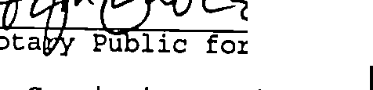

-l

I

•



'•.

BOoK716rAGE **165**



## EXHIBIT '_'A"

All and singular, all that certain piece, parcel or lot of land lying, being and situate in Litchfield, Georgetown County, South Carolina, described as 2.60 acres, on a plat entitled "Tradition Club Swim and Tennis Clubhouse Site" made for Centex Hornes, dated May 17, 1996 and recorded July 3, 1996 at Slide 174, Page 2-13, office of the RMC for Georgetown County, South Carolina, reference to which is craved hereto as forming a part 2nd parcel hereof.

. This conveyance is subject an easement for the Tradition Golf Course "cart paths" as shown on the above referenced plat.







I ,..

•

,\, .......

BO-□K-71-6-.r-iGli **-16_6 \_,'\-'.**

AFFIDAVIT OF TRUE CONSIDERATION STATE OF SOUTH CAROLINA

COUNTY OF GEORGETOWN

# Personally appeared before me_ Uf-N ,J G'.h: f L_l S 'T e_v_ _,_IP;._;a _ who being sworn says that the true consideration of the lands from

-Z."7Z-'o l-tn1..r;,1 C()5pbrt5TI0,._j to"[R..w\-1:>\T\ON A'f Wll.LB tc:..

7 o. t,..., is n11e. $ S:- c>0 Dollars, Sworn to before me this l'\i"'-day of 1 A. D. 19-1fi2_.

 *411=*

,.·.··,

I

I

I

·-j

*!*

J

·j

i

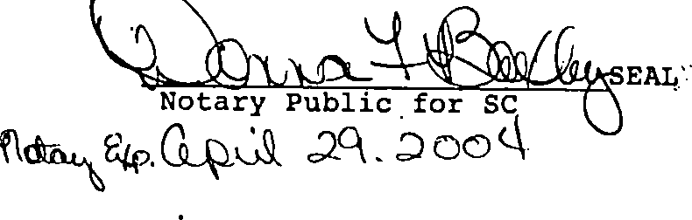

**1**,·**,**

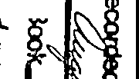

**.L** .. , •·

' • *J 1,*

\•',.

•1 ·-·..•,"

*:•'_··*

'.

I:•

..

·, ,, *:* 1·•

' i,;•

)> **5'**

**C:**

I

***N***

**C.**

•

***p***

**f/1**

p '

**ia**

*If-*

*f*

**G**

*f*r

**-:i**

***J.J***

**o()**

*t-*

.rJ-

*':c*



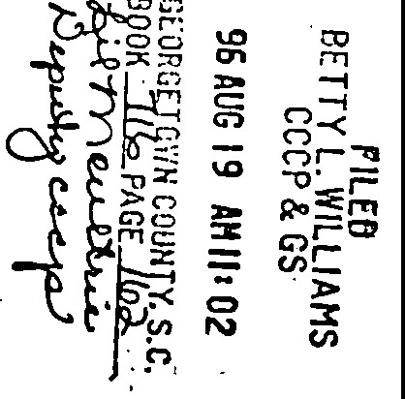

t•' .

i

**-*t*i *t***(***9*** "'

**Cl**

*r*

•• *ft -*-*-*

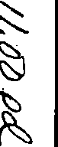

*-*f*r*i'e

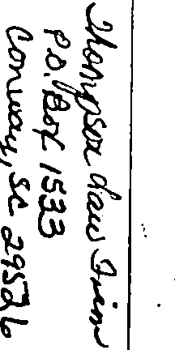

*t*.,_*-* **o~**

rf

;**L,**

***l*** •

···-----------·-·---........_ - ---·- - -----------------------· --

