00012744 .11/18/199& *B733* **PllG**

## STATE OF SOUTH CAROLINA )

)

## COUNTY OF GEORGETOWN .)

FIFTH SUPPLEMENT TO DECLARATION OF COVENANTS, CONDITIONS, AND RESTRICTIONS FOR THE TRADITION **AT** WILLBROOK PLANTATION •

This fi¥.th Supplement to the Declaration of covenants,

Conditioni, dnd Restrictions for the .Tradition at Willbrook

Plantation is made this day of *_O c:fv-'--_U)_i_V ,* 1996, by Centex

Real Estate Corporation, a corporation organized and existing under the laws of the State of Nevada, but authorized.to do business in South Carolina, (hereinafter referred to as "Declarant11)

I

.·l

**W** I **T N E S S E T H**

WHEREAS, Declarant has previously imposed upon the property described therein a certain Declaration of Covenants, Conditions,

,and Restrictions· (hereinafter "Restrictions") for the.Tradition At Willbrook Plantation. Those Restrictions are dated December 29, 1994, recorded in Deed Book 616, at page 192 and rerecorded in Deed Book 620, at page 273, Office of the RMC for Georgetown County, South Carolina: and

WHEREAS, Declarant desires by this Amendment to add and subject to said Declaration pursuant to Article V of- ·said Declaration, the property described in.Exhibit "A" which shall be held, sold and conveyed subject to the easements, restrictions, covenants, and conditions set forth in said Declaration which are for the purpose of protecting the value and desirability of and which shall run with the real property desc:ribed herein, and which shall be binding on all parties having any right, title or interest in the described properties or part thereof, their heirs, successors, successors-in-title, and assigns, and shall inure to

C11UITTY PARCB. f

: ;;;..i-

-4-40?-l



/. .

I;\..

. / •



•



**00012744 1/18/1996 B733 P117**

the benefit of each owner thereof.

NOW THEREFORE, for and in consideration of the premises

recited above, Declarant hereby covenants and agrees as follows:

* 1.· The property described in Exhibit "A" which is attached hereto and incorporated *by* reference herein shall become and is

hereby declared to be property subject to the Declaration of covenants, Conditions, and Restrictions for The Tradition At Willbrook Plantation oated December 29, 1994, and recorded in the 'need Book 616, at page 192, Office of the RMC for Georgetown County and·rerecorded in Deed Book 620, at page 273, said property being annexed pursuant to _the provisions of Article V of said Declaration.

2. It is hereby agreed that the aforesaid Declaration of·

covenants, Conditions, and Restrictions for the Tradition At

Willbrook Plantation dated December 29, 1994 shall be and the same is hereby rat'ified, confirmed and adopted in all respects, as amended, and all particulars as to those provisions expressly amended as set forth herein; and it is further agreed that this document shall, and does hereby constitute a Fifth supplement to

I

the aforesaid Declaration 'of Covenants, Conditions, -and



Restrictions for The Tradition at Willbrook Plantation with regard

* to the matters set forth herein. II

3. This Fifth Supplement to the Declaration of Covenants, Conditions, and Restrictions for The Tradition At Willbrook Plantation shall be binding upon and inure to the benefit of all parties having any right, title or interes_t in the described

properties or any part thereof, their heirs, successors,

. ' '





 •.;.

r..

I

# ' .....:.. .\· -j

00012744 11/18/1996 B733 **P118**

successors-in-title, arid assigns, and shall inure to the benefit of

**each o er** thereof.

IN WITNESS HEREOF, the.undersigned Declarant has executed this Fifth Supplement to the Declaration·of Covenants, Conditions, and

· Restrictions for The Tradition At Willbrook Plantation the day and taer first above written.

**CENTEX.REAL ESTATE CORPORATION**

I

*-1*

* - I

:]

I ' I

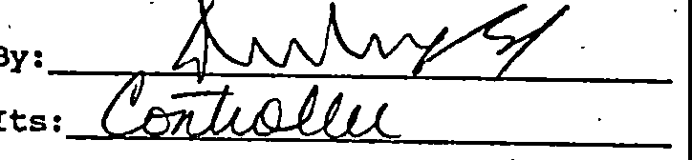

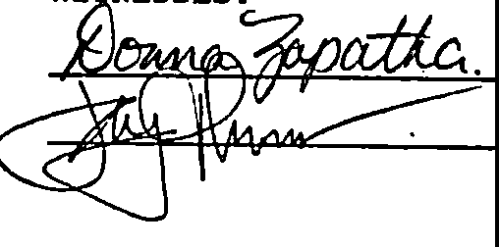

## STATE OF SOUTH CAROLINA )

couNTY oF :Qor@@'7W ) )

## PROBATE

PERSONALLY appeared before me the undersigned witness and made (s)he saw the w hin **REAL ESTATE CORPORATION,** by

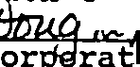

ta

**:x**

*1J*

1. its, *O I* sign, seal and as its

cor rate act and deed deliver the within Fourth Supplement to the Declaration of Covenants, conditions, and Restrictions and (s)he with the other witness witnessed the execution thereof and saw the corporate seal affixed thereto.

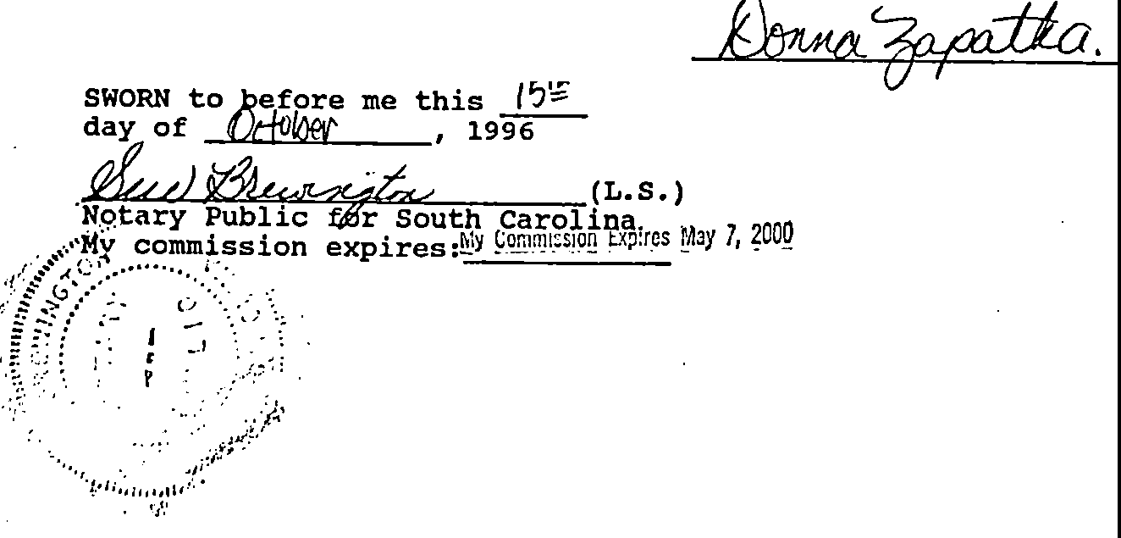

*r·*·'

•

/:>:<•,- / ,- _:.·:·:''·. ; 



I _... ·

\.

**00012744 11/18/1996 B733 P119**

Exhibit **"A"**

••

All and Singular, all that certain piece, parcel or tract of land in Willbrook Plantation., Litchfield Beach, Georgetown county, South Carolina, described ·as PHASE J, PARCEL l of the Tradition

* + Club Subdivision, containing 69 lots, all of which are more particularly shown and described on a plat of said property drawn by TRICO Envirometrics, Inc.,·dated May l, 1996 and recorded **Mays,** 1996 at slide_ 199, at page 7, office of the RMC •for Georgetown County, south Carolin'a; refer nce to which is craved as forming a part and parcel hereof,

j'

I





.*,Jr·*

•

·, •

*;:;,*

**00012744 11/18/1996 B733 P120**

•'•

;

l

-_jr·

....

# _;.,i.

-r:11

. i,•,

.·--

j ..

.·I

'-l

---\hou

00012744

RECORDED 11/18/1996 11:46A

Bk:733 Pg:116 Pages:5 Fee:9.00 State:0.00

.County:0.00 Trans:0.00 Georgetown County, SC

Betty L. Williams, Clerk of Court

'in *I* CC:

,/

!·

J:

I

i

**C**

...

·,

·!

...

**Recorded this../ti¼:' day *o:***

@4 **A.C. 1**

w.,,***•k11•ci1ee ,_.,***

**Co..**

a**In Book_7_Pai9,** .

**Auditor, S. C,**

·:

. •.

-- :}1 .-....-··