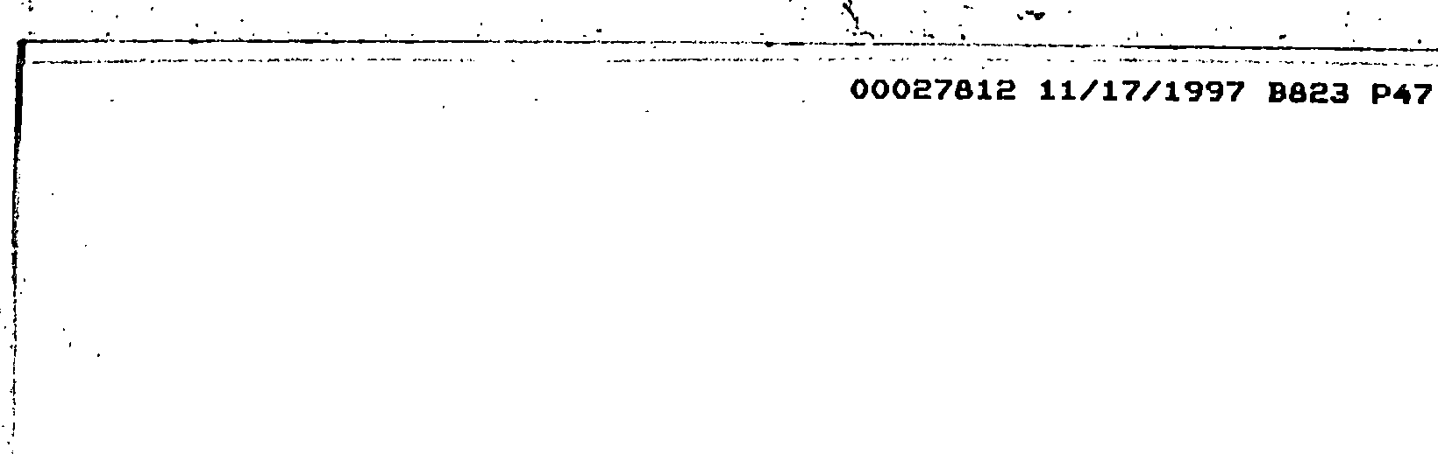•



STATE OF SOUTH CAROLINA COUNTY OF GEORGETOWN

AMENDMENT TO BYLAWS OF TRADITION AT WILLBROOK PROPERTY OWNERS ASSOCIATION, **IN .**

This Amendment to the Bylaws of Tradition at Willbrook Property Owners ·Association, Inc. is made this **/r:Jl1,...** day of

, 1997.

* . l'



•

**WITNESS ETH**

WHEREAS, The Association has previously adopted By-Laws which

, were attached to and recorded with ·the Declaration of CovenantEl, Conditions, and Restrictions for the Tradition At -Willbrook Illanta_tic,n. Those, Restrictions are dated December 29, 1994, recorded in Deed Book 616, at page 192 and rerecorded in Deed Book 620; at _page 273, Office of the RMC for Georgetown County, South

·Carolina; and

WHEREAS,. Association desires by this Amendment to amend the By-Laws, pursuant to Article **XIII** of said By-Laws, as noted herein.

NOW THEREFORE, for and in consideration of the -premises recited above, the By-Laws are hereby amended as follows:

1, Article VII of the By-Laws of Tradition· at Willbrook Plantat1on· l?rciperty_Owners Association, Inc. (Powers and. Duties of the Board of Directors) shall be amended to add the following under Section 1.

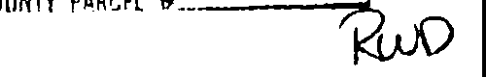1-

•



,-- I •

··-·- ' ' '-; ..._ .... ·-·--

**00027812 11/17/1997 8823 P48**

-\ '

•

1 "In addftion, to any other remedies provided herein or in the Declaration, the Board shall have the power to impose reasonable fines, which shall constitute· a lien upon the property of the violating owner and to suspend· an Owner's right to vote or to use the Common Area for violation of any

duty imposed under the Declaration, these By-laws, or any rules and regulations adopted hereunder.; provided, however,

- I nothing herein shall authorize the Association or Board of Directors to limit ingress or egress to or from a Lot. In the event that any owner of a Lot violates the Declaration, By­ Laws or a rule or regulation and a fine is imposed, the fine shall be assessed against the Owner. The failure of the Board to enforce any provision of the Declaration, By-Laws, or any rule or regulation shall not be deemed a waiver of the right of the Board to do so thereafter. The lien provided for herein may be foreclosed in the same manner as mortgages may be foreclosed pursuant to South Carolina law, in addition to any and all other remedies which the Association may have pursuant to applicable law. In addition, the Association may file a notice of lien in the public records of Georgetown County, South Carolina.

•

(a) Prior to the imposition of any fine or suspension of use of the Common Areas as s_et forth hereunder, except for based on the non-payment of assessments or violation of a provision of the Declaration for which a specific remedy is provided in_ the Der.laration, the Board or its delegate shall·serve the alleged violator with written

•

--- ----- --. --------- - -------------------

•

**00027812 11/17/1997 B823 P49**

notice describing the nature of the alleged violation and the penalty to be imposed.

(bl Notwithstanding anything to the contrary herein contained, the Association, acting by and through the Board of Directors, may elect to enforce any provision of the Declaration, these By-Laws, or the rules and regulations of the Association by self-help or by suit at law or·in equity to enjoin any violation or to recover· monetary damages or both without the necessity or compliance with the procedure set forth above. In any st.1ch action, to the extent-permissible by law, the Owner or occupant responsible for the violation of which· abat'ement is sought shall pay all costs, including

•

·reasonabl attorney's fees actually incurred."

i'·

I

,I ,, I,!

r:

l

*i·*

I

I

•

•



r.-;

# l -

2. It is hereby agreed that the aforesaid By-Laws of the

-Tradition At Willbrook Plantation Property_ Owners Association , Inc. shall be and the same is hereby· ratified, confirmed. and adopted •in all respects, as amended, and all particulars as to those provisions expressly amend_ed as set forth herein; and it is further agreed that this document shall, and does hereby constitute a first amendment to the aforesaid By-Laws of Tradition at



_Willbrook Plantation Property Owners Association, Inc. with regard to the matters set forth herein.

•



•

**00027812 11/17/1997 8823 P50**

IN WITNESS HEREOF, the undersigned has executed this Amendment ,, to By-Laws of Tradition At Willbrook Plantation Property Owners Association, Inc. the day and year first above written.

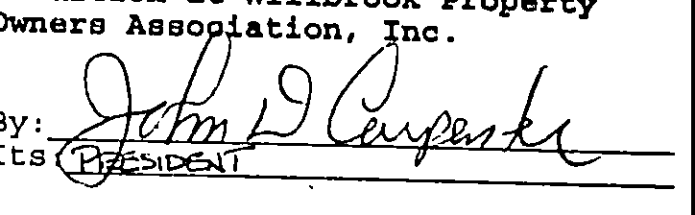

WITNESSES:

•

w

•



-- ...... ·-·- ..• J\

**00027812 11/17/1997 B823 P51** /



•

I

I.

I

STATE OF SOUTH CAROLINA )

)

COUNTY OF HTJR.R.y )

PROBATE

•

PERSONALLY appeared before me the undersigned witness and. made oath that (s)he saw the within **Tradition at Willbrook Property** Owners Association, Inc., by JPtir-! 1). C1te r-c::e, , its •

-P1Zc:S1-oe.lT sign, seal and as its corporate act and deed

deliver the within Amendment to By-Laws, and Restrictions and (s)he with the other witness witnessed the execution thereof and saw the­

corporafe seal affixed fherefo. .

SWORN to before me this *1.!i!:*

*0£= ·*

•·

1997 •

,.-,,-=-=---"",--.c,=---,!--" ,, =,,=,"'=-+-'\a-(L.S.)

forSouth'car

Notary Public ina I

My commissio,n expires: :;Qj-.;100'¥

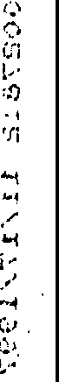\

l

•

i'

I,i.,

# ii

I

!

I



·• • • •

' ··• - .• . ,-. -

.,

l

**00027812 11/17/1997 8823 P52**

* l

\1l J12 1

RECORDED 11/17/1997

Bk:823 Pg:47 Pages:6

10:41A

. County:O.00

Fee:11.00 State:0.00

Georgetown County SC

T ans:0.00

_,,,

**fn o ;-r;.f,oc_**

r

.J/lu *al:* Willbiook..?--"

*'.t*

*j*

·-,. --

*:*.•·

C)

::

* G.ooccto.k._, JhC

OJn.t.ncl -fu ¾.:

DD *Bk t;.J ft'o IC/* ·

I

·1

. i'

'·j

1··

\

I

I·

!

:,.-

<

:.:...

k

-

le·

l

*this day* **of**

*.tL*

**'ZJ.'W:"""'f'.{.A.-** A. D *199,7*

i'.

t··

I·'

*:::.*



 



