•



###### STATE OF SOUTH CAROLINA )

)

###### COUNTY OF GEORGETOWN )

###### SIXTH SUPPLEMENT TO DECLARATION OF COVENANTS, CONDITIONS, AND RESTRICTIONS FOR THE TRADITION AT WILLBROOK PLANTATION



•

# l:

j

l

### j

J •

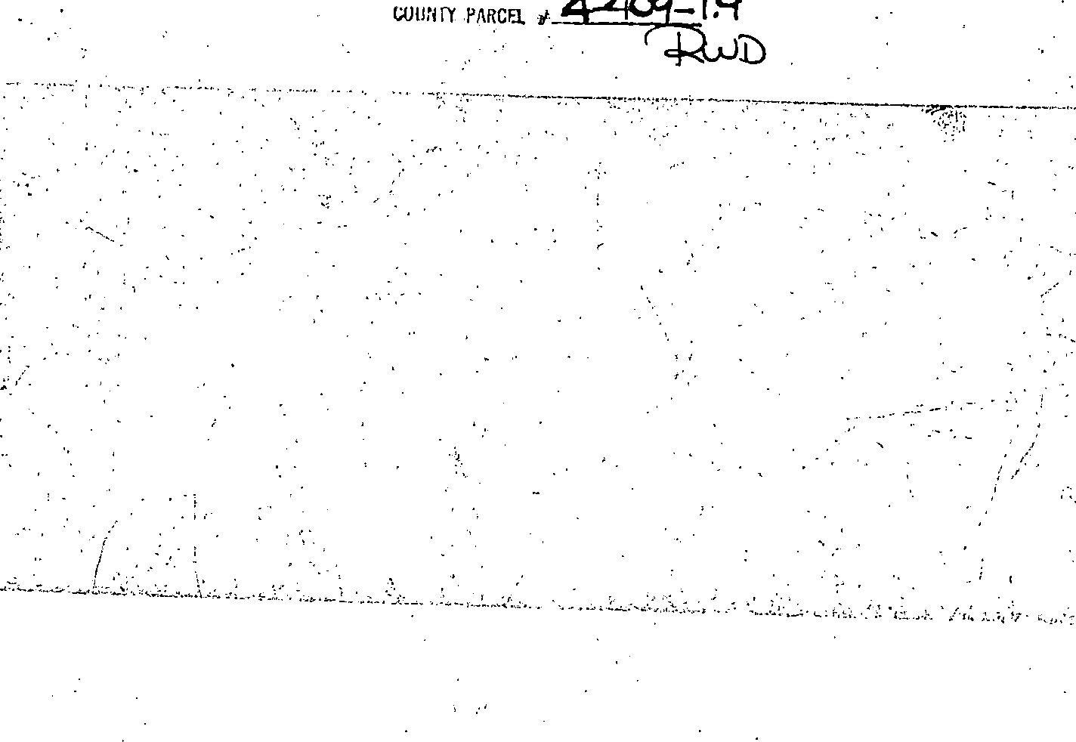

. and assigns, and shall inure to the benefit of each owner thereof.

NOW THEREFORE, for and in consideration of the premises recited above, hereby covenants and agrees as follows:

•

This Fifth Supplement to the Declaration of Covenants, Conditions, and Restrictions for the

Tradition at Willbrook Plantation is made this day of Dece t'Yl ber:::; 1997, by Centex Homes, aNevada General Partnership, authorized to do business in South Carolina, (hereinafter referred to as "Declarant") •

WITNESS **ETH**

WHEREA,S, Declarant has previously imposed _upon the property described therein a certain·

Declaration of Covenants, Conditions, and Restrictions (hereinafter "Restrictions") for the Tradition At Willbrook Plantation. Those Restrictions are dated December 29, I994, recorded in Deed Book

. '

\ . :· .

616, at page 192 and rerecorded in Deed Book 620, at page 273, Office of the RMC for Georgetown County, South 'Carolina; and

* WHEREAS, Declarant desires by this Amendment to add and subject to said Declaration pursuant to Article Y of said Declaration, the property described in Exhibit "A" which shall be held; sold and conveyed subject to the easements, restrictions, covenants, and conditions set forth in said

Declaration which are for the purpose of protecting the value and desirability of and which shall run with the real property described herein, and which shall be binding on all parties having any right, title or interest in the described properties or part thereof, their heirs, successors, successors-in-title,



Declarant

•

·.•.

#### i

•

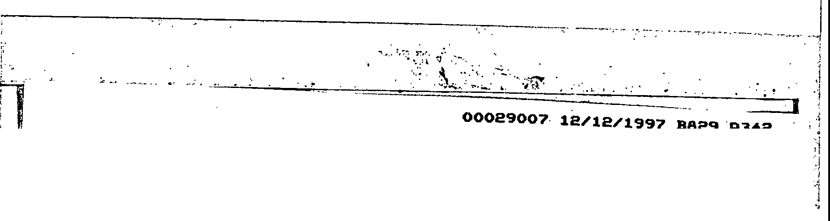

**00029007 12/12/1997 B829 P342**

1. The property described in Exhibit "A" which is attached hereto _and incorporated by

,_.

reference herein shall become and is hereby declared to be property subject to the Declaration of

Covenants, Conditions, and Restrictions for The Tradition At Willbrook Plantation dated December .

29, 1994, and recorded in the Deed Book 616, at page 192, Office of the RMC for Georgetown County and rerecorded in Deed Book 620, at page 273, said property being annexed pursuant to the provisions of Article V of said Declaration.

* 1. It is hereby agreed that the aforesaid Dec!arktion -"or _Covenants, Conditions, and Restrictions for the Tradition At Willbrook Plantation dated December 29, 1994 shall be and the same is hereby ratified, confirmed aiid adopted in all resp cts, as amended, and all particulars as to those provisions expressly amended as set forth herein; and it is further agreed that this document shall, and does hereby constitute a sixth supplement to the aforesaid Declaration of Covenants, Cimditions, and Restrictions for The Tradition at Willbrook Plantation with regard to the matters set forth herein.

•

* 1. This Sixth Supplement to the Declaration of Covenants, Conditions, and Restrictions for The Tradition At Willbrook Plantation shall be binding upon and inure to the benefit of all parties having any right, title or interest in the described properties or any part thereof, their heirs, successors, successors-in-title, and assigns, and shall inure to the benefit of each owner thereof.

•







•



**00029007 12/12/1997 829 P343**

IN WI1NESS HEREOF, the undersigned Declarant has executed this Sixth Supplement to

the Declaration of Covenants, Conditions, and Restrictions for The Tradition At Willbrook

,,

i

:,1

:l

Plantation the day and date first above written.

**CENTEX HOMES, A NEVADA GENE PARTNERSHIP**

By:,_·.-+1. "-'"'.:.....;"""-""-"' :..:..:.-""r---­

lts: ,._..."-'-"' .J<...,._,_, -----

·,.., : 'WITNESSES_: , .

'

•

*u*

,·

i'

!

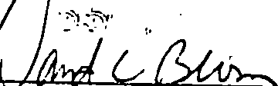

•

###### STATE OF SO'UTH CAROLINA )



coUNTY oF

lJo

*r* r7 )

###### PROBATE

PERSONALLY appeared before me the undersigned witness and made oath that (s)he saw the ith,ip **CENTEX HOl};IES, A NEVADA GENERAL PARTNERSHIP,** by



* -
* its, *Cond:tD} lc:c*

sign, seal and as its corporate act and deed

deliver the within Sixth pplement to the Declaration of Covenants, Conditions,·and Restrictions and (s)he with the other witness witnessed the execution thereof and saw the corporate seal affixed

thereto.

* SWORN to before me this *5'1-L*

day of December, 1997

JcvjJ

•

I

i

I

. b- .S.)

Notary Public for South Carolina

My commission expires: *tof lf*

l

)



### '''\i •

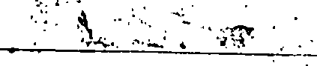

**00029007 12/12/1997 B829 P344**

I*!*i*·*

l·l

Exhibit "A"

All and Singular, all that certain piece, parcel or tract of-land in Willbrook Plantation, Litchfield Beach, Georgetown County, South Carolina, described as PHASE 9, PARCEL 2 of the Tradition Club Subdivision, containing lots, all of which are more particularly shown and

described on a plat of said property drawn by Trico Engineering Consultants, Inc., dated I *l* I y ,

1997 and recorded April 25, 1997 at slide 229, at page i'0,,office. or'.the RMC for Ge rgetown

County, South Carolina, reference to which is craved as forming a part and parcel hereof.

,,.

,,::,

•



,:.

*•:>*

J,)

c

._ ! (Q)

-

-·

' ;,,

·\ -

! **:;1**

##### ,.:•l ..,

:·1 ;;,,

··1 r,,;

,,:I ,,.

: i

,·J t,r;

. *:1* ,,i



. ·., ,•, ... ,;,

•

·,·, ,' ·,1 ('

• ,..•c·1·.·

:·.·1,

'i,i .. ..

*:·•* 1:•

.;

-

j

,.,

.,.,

•

 



.... --· - - --- - -

.,

=

,...........

--,--·-·-··--•--------•-- -

**00029007 12/12/1997 B829 P345**

I­ •...... .. .

**'11** -

r

\il29007 12)12/1997 **02:49P**

·-..,l

·-.

.-!

_,.i

I. RECORDED,..41··Pa·g·e··s··:·5······. · ·

····••:••..

.

'

,.

GCeoou!r1gtyet.ooi'.:rMn OCl'e oI

u*er*skc **o**t**f Coul't**

*-*/­

\ '

rI -

rI·

I -

t'.

## I·

·... ***·�J***

'it'·

## '·d_'._j

l!

...._.· ;,

i:.

* I Cf ..

d:c.( *+JtfhuA*

;1,

.,-·

. *-:*

-,

,·,; ·•·_

-i};-[!

'l

1,L

I

*:,* ,*;,* .•· • l

•-" • 1.

'?h

*i-U-f-Pt c:./* C-0*V* .Q..tc,

q *y?QAuQ* '"ch

/

*r:* ..'. .".

!-·'

-- _._·:...-

0

0

0,,,

**!j,J**

·

0

i **L--.**

**-1\**

c.-Li.fuy-,. CJ,u.,6 w&b,o,

**."**,**<**,**f**·**!**

*/*...

:l,

f,

*(*

*v*

''rJ°"1

C!,

O'

,<,._J

<i.

*ech; ayof*

&. $-., - .............

.*D 19..2z*

Auditor, *Georgetown* Co., S.C.

..

*-:,-*•..

'

#### --·-'j:·1

/

*}*

------·/

·i

### 1

·-:j

··1

:.. ,·- ._,.. ,L n--------., -·•·- ,_ , .. - --- .,.

•• • • •

.<.. ,.._..·-:;: L-->· d..-,·*::·:;.:,,-::·,:·::_·--*·-.-: ::-.**..<J** ----