# I

I

:j

I.

·,'

I

STATE OF SOUTH CAROLINA )

) COUNTY OF GEORGETOWN )

**00000243 01/08/1998 B837 P33**

SEVENTH SUPPLEMENT TO DECLARATION

OF COVENANTS, CONDITIONS, AND ,I

RESTRICTIONS FOR THE TRADITION AT WILLBROOK PLANTATION

This Seventh Supplement to the Declaration of Covenanis, Conditions, and Restrictions for

•

the Tradition at Willbrook Plantation is made this A day of January, I998, by Centex Homes,

a Nevada General Partnership, authorized to do business in South Carolina, (hereinafter referred to I:

as "Declaran!") .



"

W_ITN ESS **E'ro**

WHEREAS, Declarant has previously imposed up?n the property described therein a certain

·Declaration of Covenants, Conditions, and Restrictions (hereinafter "Restrictions") for the Tradition

At Willbrook Plantation. Those Restrictions are dated December 29, 1994, recorded in Deed Book

616, t page 19.2 and rerecorded in Deed Book 620; at page 273, Office of the RMC for Georgetown County, Sout_h Carolina; and

WHEREAS, Declarant desires by this Amendment to add and subject to said _Declaration

- . **t** •

pum1ant to Article Vofsaid Declaration, the property described in Exhibit "A" which shall be held, sold and conveyed subject to the easements, restrictions, covenants, and conditions set forth in said Declaration which are for the purpose of protecting the value and desirability of and which shall run with·the real property described herein, and which shall be binding on all parties having any right, title or interest in the described properties or part thereof, their heirs, successors, successors-in-title, and



*I:*

assigns, and shall inure to the benefit of each.owner thereof.

•

NOW THEREFORE, for and in consideration of the premises recited above, Declarant hereby covenants and agrees as follows:

COUNIY PAHGU. *I* + .. ;u





.1, .*./*



\" •

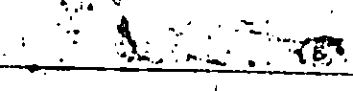

**00000243 01/08/1998·8837 P34**

1. The property described in Exhibit "A" which is attached hereto and incorporated by **reference herein** shall become and is hereby declared to be property subject to the Declaration of Covenants, Conditions, and Restrictions for The Tradition At Willbrook Plantation dated December 29, 1994, and recorded in the Deed Book 616, at page 192, Office of the RMC for Georgetown

County and rerecorded in Deed Book 620, at page 273, said property being annexed pursuant to the provisions of Article V of said Declaration.

1. It is hereby agreed that the aforesaid Declaration of Covenants, Conditions, and

,,

•

Restrictions for the Tradition At Willbrook Plantation dated December 29, 1994 shall be and the

same is hereby ratified, confinned and adopted in all respects, as amended, and all particulars as to

those provisions expressly amended as set forth herein; and it is further agreed that this document

shall, and does hereby constitute a seventh supplement to the aforesaid Declaration of Covenants,

CQnditions, and Restrictions for The Tradition at Willbrook Plantation with regard to the matters set

..

forth herein. • •

3. This Seventh Supplement to the Declaration of Covenants, Conditions, and Restrictions for The Tradition At Willbrook Plantation shall be binding upon and inure to the benefit of all parties having any right, title or interest in the described properties or any part thereof, their **heirs,** successors, successors-in-title, and assigns, and shall inure to the benefit of each owner thereof.



.. ,

;-

-

.;--*·::*-*r,*-*r.*-*•.*-'', -..-. --------'--'-- '--\•:---------'--'"-- ***.\:'·.Afil'.• _, ,·:*** _



:}··:'{\ · •,.

t. ":.. ·,-r,.•...

**00000243 01/08/1998 B837 P3S**

I

*I*

j

!

IN WITNESS HEREOF, the undersigned Declarant has executed this Seventh Supplement

to the Declaration of Covenants, Conditions, and Restrictions for The Tradition At Wtllbrook Plantation the day and date first above written.

**CENTEX HOMES, A NEVADA GENE L PARTNERSHIP**

'

·············*I*·�···. ····························································

*I'.*

* 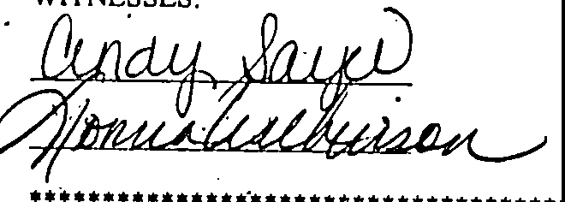

STATE OF SOUTH CAROLINA ' COUNTY OF I )'"'7

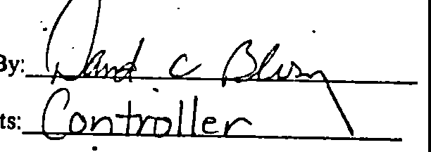PROBATE

: ...

_PERSONALLY appeared before me the undersigned witness and made oath that (s)he saw the within. **CENTEX *Hm'?!;)S,* A NEVADA GENERAL PARTNERSHIP,** by

JJav\cl *C..* d:> less·1 ts,ntrt)) ***)t"*** v: sign, seal and as its corporate act and deed

deliver the within Seventh upplement to the Declaration of Covenants, Conditions, and Restrictions

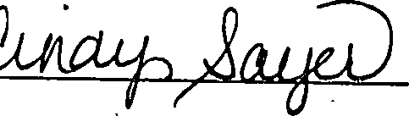and (s)he with the other witness witnessed the execution thereof and saw the corporate seal affixed thereto.

SWORN to before me this -2:,,,,..

day of January, 1998 .

•• *fu.*  **(L.S.)**

Notary Public for South Caro a My commission expires:_ *{O, 3k*

0



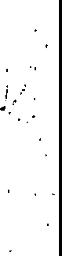

.

l.,,.·-- --.. o.; .. ·_.,;_,-...., -- - .:,. _•;,,.·

**oooooe43 01/08/1998 B837 P36**

•

Exhibit "A"

#### All and Singular, all that certain piece, parcel or tract of land in Wtllbrook Plantation, Litchfield Beach, Georgetown County, South Carolina, described as PHASE 5, PARCEL 1 of the Tradition Club Subdivision, containing 49 lots, all of which are ore particularly shown and described on a plat of said property drawn by Trico Engineering Consultants, Inc., dated June 18,• 1997 and recorded.July 2S, 1997 at slide 238, at page 9, office of the RMC for Georgetown County, South Carolina, reference to which i craved as forming a part and parcel hereof.

•

i J

l C t

!

•



,..:·

*/_*/ •.

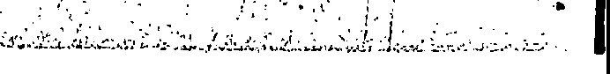••

\

*- ·._.,:<·..J<".,* ''.....-'._,:j£';···•.-·

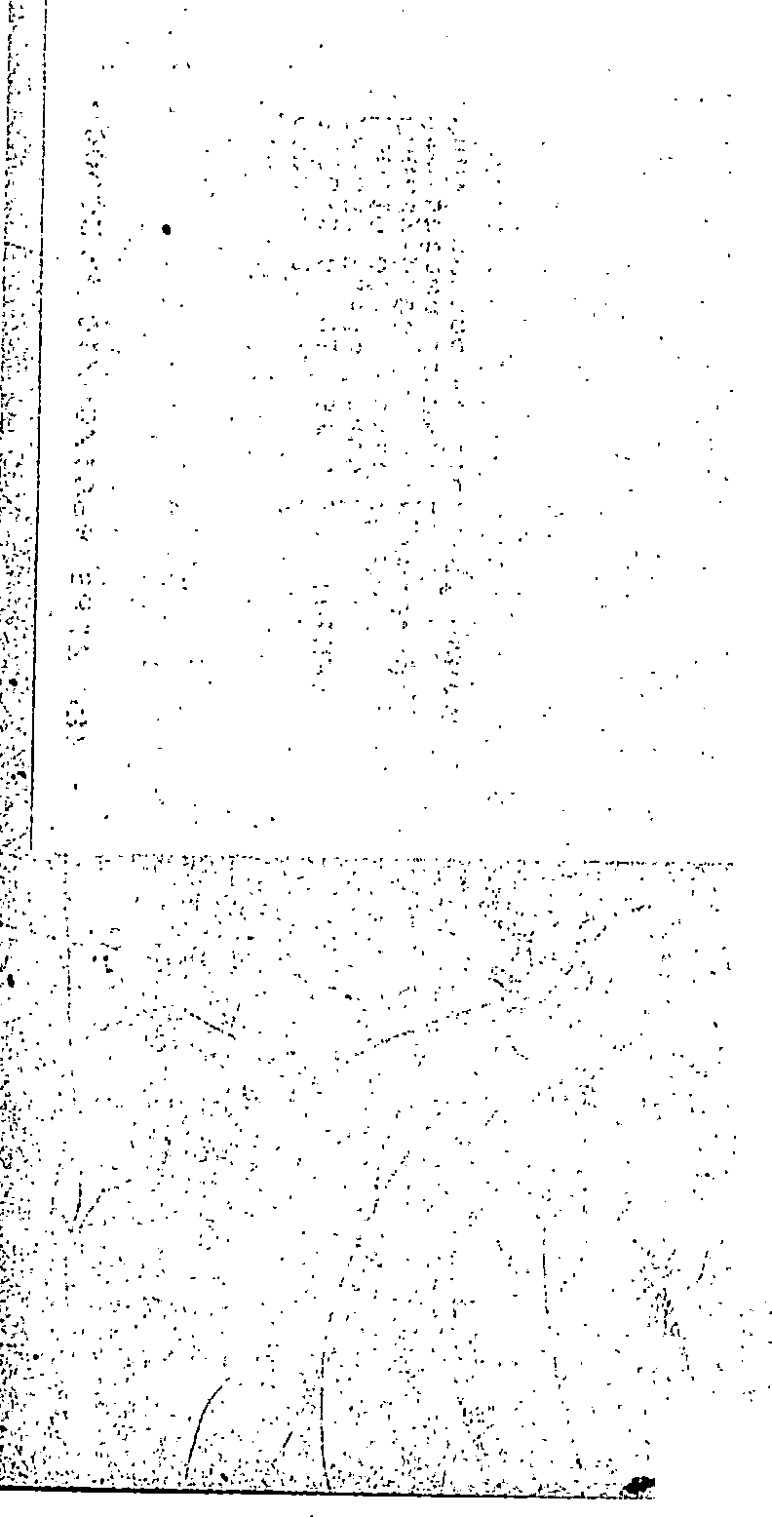

* + ::, ' .... _ ·- --·-

*I:* ,, ·...,. *.;·-:*

• -•:.. - ··= - •• ·-.

-' ----= 111

• _•,,; -- -=:,..,';:'...-;,,:r.,t. -•...::,,..:.... :.,.-;w.:a.;.._....

**00000243 01/08(1998 B837 P37** ..

--_,\\ / *r-:,*

**\**0**4**000**7**02**4**43 -\

.. *·:* .

## ·-·-; i

.:·{,:.

RECORDED 01/08/19 8 . **10:52A**

Bk:837 Pg:33 Pages:5 .

Fee:10.00 State:0.00

\\

: ··{:

-,

*i:.*

i*r*

-_ }.--.

*_;.:*

#### i.:

:.,·

!':·

:i

.o,i,·



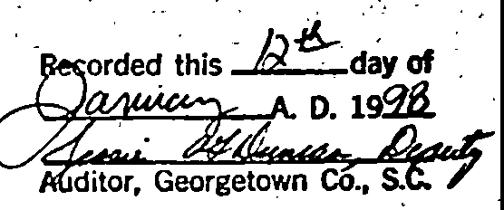- "• -I''

, ..

;'_:'

C•

-,·,

,.J·.

--<

:::·

/"

County:0.00 Trans:0.00 - . i; Geo·,-getown County SC , Ruby Ann Moore, clerk **of Court** /· ·:.

7Y\ -w\-



;,;; .•

. . ..

*··.-J.l i* ,.

f( -+o- \ *CNV* etc.

·**Ph 5** *faAaL* **l 4l\ Lu-ls**

, ,tG.:tu-- . •

*!* ,..-··,

*,... ,..r,.*

*_..-..r:.=-:*

,·,,

...

/- *:*

i'j

')

### ..·--i

··_:·

i:··_

### j',.

r.'

..l--- ?. -

:·; •

'l)

-:

I.

I

*(*..

*·1:*

*:*'*-:·*

.;/.

/

# ---- ·,:J

. . l/.

-- j

# .t.

,·

{/'

.,, ,.

-,

-

## '·Ji

-------====·c:•-:.,:-,,.,:-,7;,,C,",,.'.0:0.:.-:7':•·:.:-•2;•·j_:;:;-·:•i,;<''., ,::;-.",,\"\,! :-:._:, :_..: :•,:·.";,.-TS .•.::, ,•";".;'"!'",•.:c'";,-;i:•,- .-.,,::c-..".°."',, - -- ----'---'----------'--'-"'---·-•_,-CcJ·t L: =;1:::;: ;:i; d.,;:,; 5,;;;.: :;:;: :-:.s;..:,; ';Jill

• • • •