-,, ----,-------,-------.,-----,---------,..... :,-,--:::, ·.:-,.-.; . ,_. ,..,..-.- - .- ·.-,, • -·-·- --·-- -

·•

t . *•. :* .-. • *- -:- .: ·:_- ,.. --* ....,- *i*

*r*..------ '-----------------,----,----------------------



**00000244 01/081'1'9'98 8837 P38**

I

,f. r *(*

(,

k

i

r

##### STATE OF SOUTH CAROLINA )

)

##### COUNTY OF GEORGETOWN )

##### EIGHTII SUPPLEMENT TO DECLARATION OF COVENANTS, CONDITIONS, AND RESTRICTIONS FOR THE TRADITION AT WILLBROOK PLANTATION

!ii

This Eighth Supplement to **the** Declaration of Covenants, Conditions, and Restrictions for the Tradition at Willbrook Plantation is made this *,;;2...._* day of January, 1998, by Centex Homes, **a**



t'

**Nevada** General Partnership, authorized to do business in South Carolina, (hereinafter referred to as

### i·

i "Declarant")

,,..



**WITNESSETR**

WHEREAS, Declarant has previously imposed upon the property described therein a certain Declaration of Covenants, Conditions, and Restrictions (hereinafter "Restrictions") for the Tradition



,.'

I'

I

At,Willbrook Plantation. Those Restr;ictions are dated December 29, I994, recorded in Deed Book

_616, at page Hr.iand rerecorded in Deed Book 620, at page 273, Office of the RMC for Georgetown County, South Carolina; and

WHEREAS, Declarant desires by this Amendment to add and subject to said Declaration

pursuant to Article V of said Declaration, the property described in Exhibit "A" which shall be held, sold and conveyed subject to the easements, restrictions, covenants, and conditions set forth in said Declaration which are for the purpose of protecting the value and desirability of and which shall run with the real property described herein, and which shall be binding on all parties having any right, title or interest in the described properties or part thereof, their heirs, successors, successors-in-title, and·. assigns, and shall inure to the benefit of each owner thereof.

•

NOW THEREFORE, for and in consideration of the premises recited above, Declarant hereby

covenants and agrees as follows:

# courm

*JI* -4C:fl-l

PARGU '-

- .'

*I*' " .-::*:*_. \ \l.·'-

•

''

,

•

* + 



**00000244 01/08/1998 8837 P39**

1. The property described in Exhibit "A" which is attached hereto and incorporated by reference herein shall become and is hereby declared to be property subject to the Declaration of Covenants, Conditions, and Restrictions for The Tradition At Willbrook Plantation dated December 29, 1994, and recorded in the Deed Book 616, at page 192, Office of the RMC for Georgetown County and rerecorded in Deed Book 620, at page 273, said property being annexed pursuant to the provisions of Article V of said Declaration.
2. it is' hereby agreed that the afor said Declaration of Covenants, Conditions, and

I,

Restrictions for the Tradition At Willbrook Plantation_ dated December 29, 1994 shall be and the same is hereby ratified, confirmed and adopted in all resp cts, 'as amended, and all particulars as to

. those provisions expressly amended as set forth herein; "and it is further agreed that this document shall, and does hereby .constitute a eighth supplement to the aforesaid Declaration of Covenants,

C ndjtions, an Restricti_ons fm,The Tradition at Willbrook Plantation with regard to the matters set •

i

1

forth herein.

* + 

3. This Eighth S pplement to the Declaration ofCovenaI\ts, Conditions, and Restrictions for

J The Tradition At Willbrook Plantation shall be binding upon and inure to the benefit of all parties

I ,



i

I;

having any right, tie or interest in the described properties or any part thereof, their heirs, successots, successors-in-title, and assigns, and shall inure to the benefit of each owner thereof.

••





' _.-.:. ·-

, -.

i-

'i..

•

## t-,

***r:*** - /

L:_c

·'

·\

1:

J,.-.. 

*'(,*



',. :::•: :

•

*·:* t_.·· -:... : .0m.-·...*.:* .

**00000244 01/08/1998 8837 P40**



IN WITNESS HEREOF, the undersigned Declarant has executed this Eighth Supplement to the Declaration of Covenants, Conditions, and Restrictions for The Tradition At Willbrook Plantation the day and date first above written,

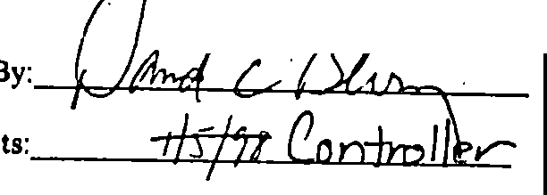**CENTEX HOMES, A NEVADA GENE PARTNERSHIP** •

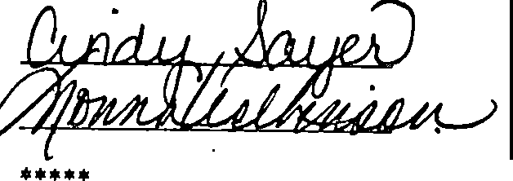•

••• * ••••••••••••••••***•• *•• *••••••••••••*•••••••••**•••••*••••••••••••••••••••

STATE OF SOUTH CAROLINA )

)

COUNTY OF IJ-orc'1 )

PROBATE

PERSONALLY appeared before me the undersigned witness and made oath that (s)he saw the within **CENTEX HOr:ES, A NEVADA GENERAL PARTNERSHIP,** by

Gbvid *C tf;*less-, *its.nm,,,.,c* sign, seal and as its corporate act and deed

deliver the within Eight upplement to the Declaration of Covenants, Conditions, and Restrictions

and (s)he with the other witness witnessed the execution thereof and saw the corporate seal affixed thereto,

**SWORN** to before me this day of January, 1998

•

#### c'llo.00. .S.)

/4

Notary Public for South Carol1a  My commission expires: *1/) g*

. ••,/

*-* / / ; .• -

*·.II *  •

*\.;{:......'* ;' : ::. ·_ .'·,. *( r -* .", *_./.* - t.: .: _:'. .J -·'---:.. :;_,:,: - --; ,: *1 ...*

* + 



**00000244 01/08/1998 B837 P41**

### Exhibit "A"

All and Singular, all that certain piece, parcel or tract of land in Willbrook Plantation, Litchfield Beach, Georgetown County, Souih Carolina, ciescribed as PHASE 6, PARCEL I of the Tradition Club Subdivision, containing 30 lots, -all of which are more particularly shown and descnoed on a plat of said property drawn by Trico Engineering Consultants, Inc., dated July 8, 1997 and recorded August 11, 1997 at slide 240, at page 10, office of"the RMG for Georgetown County, South Carolina, reference to which is craved as forming a part and parcel hereof.

•

* + ​

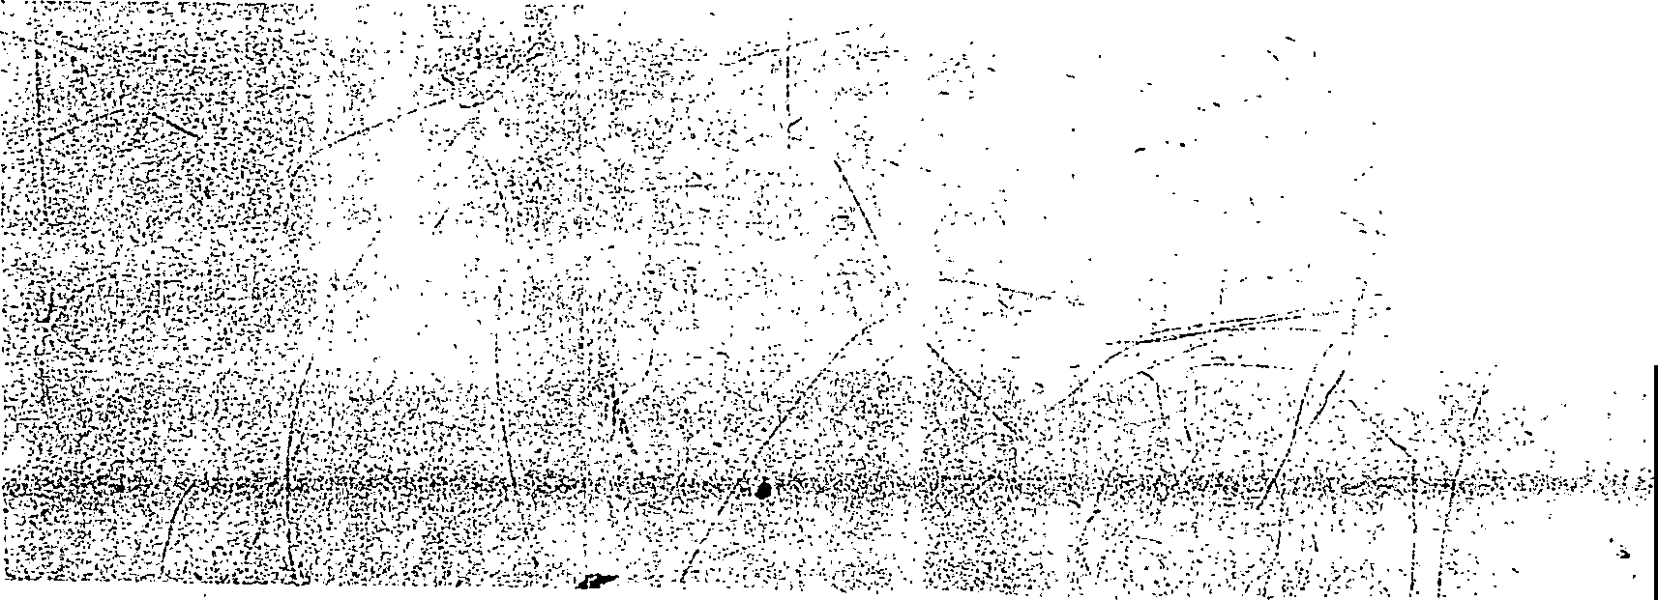

. ;: ;;-;:_:.:;-;::- --

.: -:-""'-- -

*I*





,. :. • •

**00000244 01/08/1998 B837 P42**

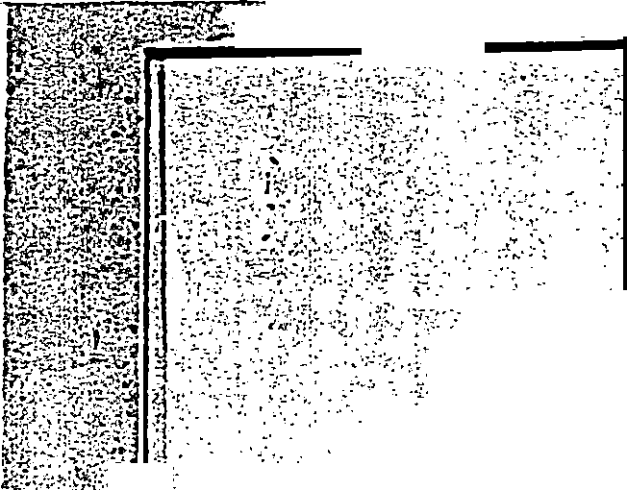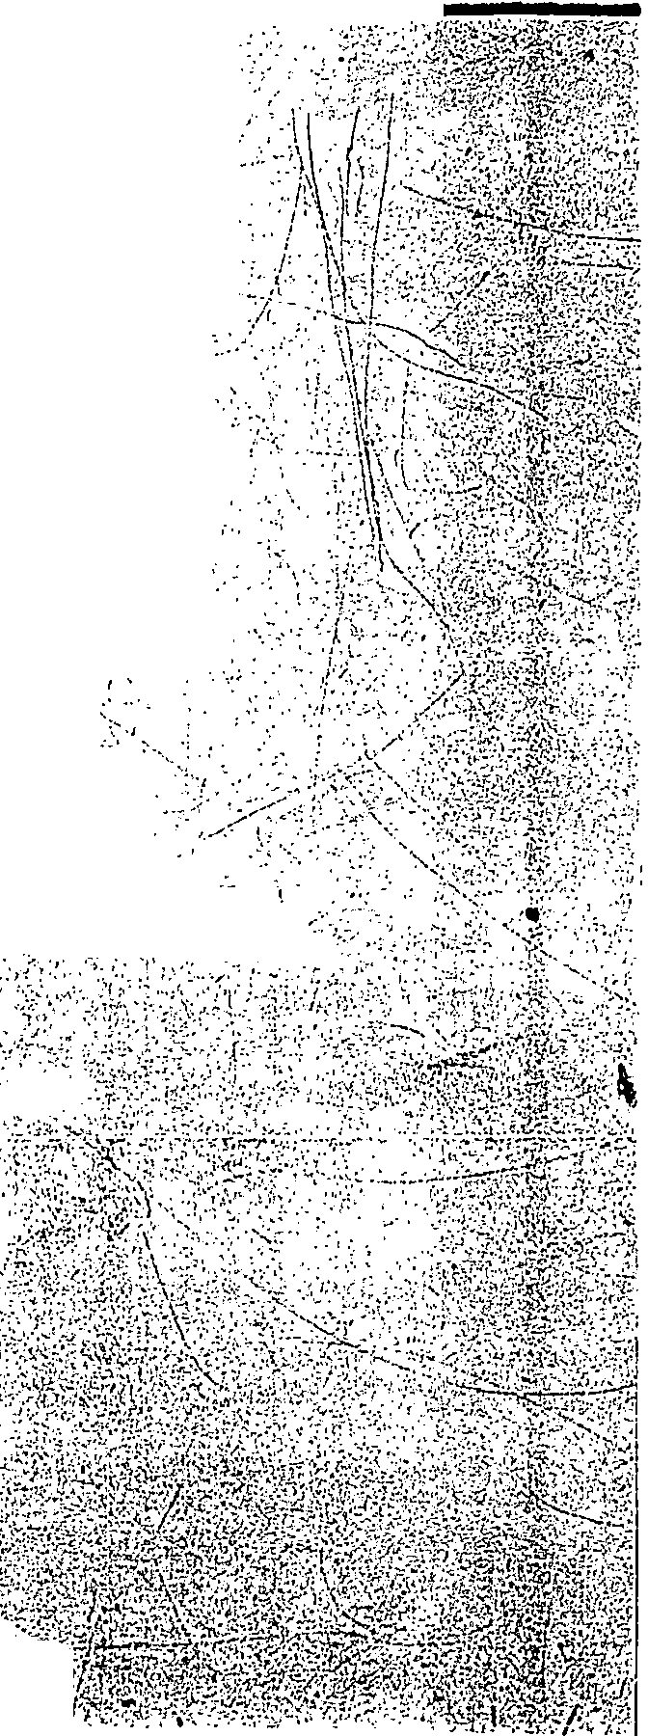

RECORDED ot;oe/1998

\ Jo J\

Bk:837 Pg:38 Pages:5

##### 10:53A

.':.

:_):\-.:;,.

·-.,,..-:;

f**f.**.**.**'**g**.:**;;**'<**;.f** n**fr:**J**t**:**"**4**•·l fjl**

f;,.t rf"l•c?:,-.

Fee:10.00 State:0.00 County:0.00 Trans:0.00 Georgetown Count i SC

o ,

Yf·

I

'i,, I

,.,

·'·

·,,• .

c_ r±,/2'. *·{* (Jn11/)



**:.o·**

0,.

t

4

4

0

'-I

/

*0*

o,::

**C.•**

,,,

**·:O**

'"-<

0.,

***C:>***

*dj*

*>I ·,:.,*

'•°,J

f$J'.I

-

*?i\-""* C:..'--1.fp- bH:.1 Cuv *-12.l-c._*

3 o Lo+s Ph Cc, POllc.Ji l

# --. \ -.:·-t,

. :·.... \.·.,' ..\ ... •.

•.J

,· *:)* 10.cl.:_,Ll,.-,.; Q u._; .b

## r/·\\;·-

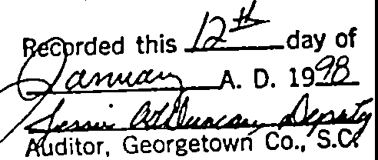

·- ,:-:-:.-.,,,-:::,.-._**7'"",**.,-----

.. 1;

,,

,•·.'•'·'. ' .:;■:- ::,:\\f{Jt