

000001495 02/02/1999 BD094 P00108

STATE OF SOUTH CAROLINA )

)

COUNTY OF GEORGETOWN )

NINTH SUPPLEMENT TO DECLARATION OF COVENANTS, CONDITIONS, AND RESTRICTIONS FOR THE TRADITION AT ' WILLBROOK PLANTATION

This Ninth Supplement to the Declaration of Covenants, Conditions, and Restrictions for the Tradition at Willbrook Plantation is made this 28th day of January, 1999, by Centex Homes, **a** Nevada General Partnership, authorized to do business in South Carolina, (hereinafter referred to as "Declarant")



''

**WITNESSETH**

WHEREAS, Declarant has previously imposed upon the property described therein a certain Decl tion of Covenants, Conditions, and Restrictions (hereinafter "Restrictions") for the Tradition

* At Willbrook Plantation. Those Restrictions are dated December 29, 1994, recorded in Deed Book 616, at page 192 and rerecorded in Deed Book 620, at page 273, Office of the RMC for Georgetown County, South Carolina; and

WHEREAS, Declarant desires by this Amendment to add and subject to said Declaration pursuant to Article V of said Declaration, the property described in Exhibit "A" which shall be held, sold and conveyed subject to the easements, restrictions, covenants, and conditions set forth in said Declaration which are for the purpose of protecting the value and desirability of and which shall run with the real property described herein, and which shall be binding on all parties having any right, title or interest in the described properties or part thereof, their heirs, successors, successors-in-title. , and assigns, and shall inure to the benefit of each owner thereof.

NOW THEREFORE, for and in consideration of the premises recited above, Declarant

hereby covenants and agrees as follows:

GEoRccrowN couNTY PARca , 4 -Llo9- I. I.3

*"I:_ vJ i]*

•



reference herein shall become and is hereby declared to be property subject to the Declaration of Covenants, Conditions, and Restrictions for The Tradition At Willbrook Plantation dated December 29, *1QQ4;* and recorded in the Deed Book 616, at page 192, Office ofihe RMC for Georgetown County and rerecorded in Deed Book 620, at page 273, said property being annexed pursuant to the provisions of Article V of said Declaration.



000001495 02/02/1999 BD094 P00109

I. The property described in Exhibit "A" which is attached hereto and incorporated by

* + 2. It is hereby agreed that the aforesaid Declaration of Covenants, Conditions, and

•. _ Restrictions for the Tradition A Willbrook Plantation dated December 29, 1994 shall be and the same is hereby ratified, confirmed and adopted in all respects, as amended, and all particulars as to those provisions expressly amended as·set forth herein; and it is further agreed that this document

shall, and does hereby constitute a ninth supplement to the aforesaid Declaration of Covenants,

' '

Conditions, and Restrictions for The Tradition at Willbrook Plantation with regard to the matters set forth herein.

3, This Ninth Supplement·to the Declaration of Covenants, .Conditions, and Restrictions for

*:* .

* + . The Tradition At Willbrook Plantation.shall be binding upon and inure to the benefit of all parties having any right, title or interest ··in the described properties or any part thereof, th ir heirs,
  + successors, successors-in-.title, and assigns, and shall inure to the benefit of each owner thereof.

i ;·

I;,:

J~,•c

I

•

. .

''.' :,- ··: ·::··., ,J·-: +:· .. -•"\ ,..: ; • ·; ';. ·'.·• .. -- ,"".<

*/*

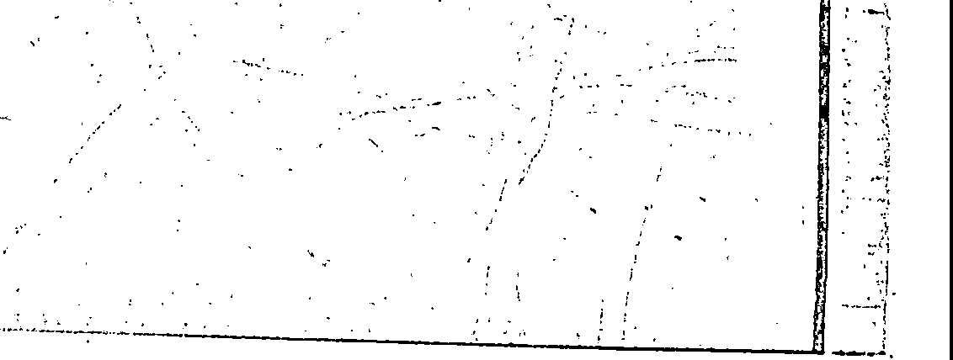

 .. *.:*



000001495 02/02/1999 8D0946 P00110

IN WITNESS HEREOF, the undersigned Declarant has executed this Ninth . Supplement to the Declaration of Covenants, Conditions, and Restrictions for The Tradition At Willbrook Plantation the day and date first above written.

**CENTEX HOMES, A NEVADA**

**:EN**

Its: 4-:J,zrAtJC-:5,e;p

WITNESSES:

. */J1(bM,{A).*

*C\ A.* J:k!>,AS

••••••••••••••••••••••••••••••••••••••••••••••••••••••••••••••••••••••••••••••

STATE OF SOUTH CAROLINA )

)

COUNTY OF H_O_R_RY _ )

PROBATE

1 ••

PERSONALLY appeared before me the undersigned witness and made oath that (s)he saw the within **CENTEX HOMES, A NEVADA GENERAL PARTNERSHIP,** by

Hampton Pitts its, Asst. Secretary sign, seal and as its corporate act and deed

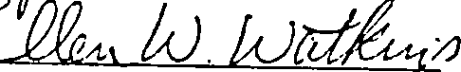deliver the within Ninth Supplement to the Declaration of Covenants, Conditions, and Restrictions and (s)he with the other witness witnessed the execution thereof and saw the corporate seal affixed thereto.

SWORN to before me this 28th

day of January , 1999.

---:PP,1uL *J..* \Ji;)n, As (L.S.)

Notary Public for South Carolina

My commission expires: 12/8/2007

!- ll ••

\·-

• -• • l, •T•-



• ;,.r,;_:_F_7-"'"':_-..:•~_·.;_."_;·9? •- :..-:o..:·. :.. ..:. ;:_-·_::... _/-:--,--;: ;-:-,::7;.:..:.:_.::."' •.!.::._•••··._••,;•..*•*.*-:t-.'.,:;,-'·:"c·*_-._,::-·:!·-'-'"t'-w:_"_r.-_.:_:_:7":-':,_;-::__::-:../~__:...;:'----':'--'-•-,. _:



!

..-:-:::;-:-•-•_,_•.,_,•-·-•-·-•-·- --·-•-:-t:,11

000001495 02/02/1999 BD094G P00111

Exhibit "A"

•

* ..



All and Singular, all that certain piece, parcel or tract of land in Willbrook Plantation, Litchfield Beach, Georgetown County, South Carolina, described as PHASE 9, PARCEL I of the Subdivision of Parent Tax Map No. 4-409-01, known as the Tr.idition Club Subdivision, located in

* Willbrook Plantation, Propeny of Centex Homes, a Nevada General Panncrship, located in Litchfield Beach, Georgetown County, South Carolina, containing 22 lots, all of which arc more particularly shown and described *Dn* a plat of said property drawn by Trico Engineering Consultants, Inc., dated November 10, 1998 and recorded November 12, I998 at slide 292, at page 7, office of the Register of Deeds f r Georgetown County, South Carolina, reference to which is craved as forming:a _part and parcel hereof.

r •

l, .

*:..,.i..o:.*

i

I

i

* .·..:.

' '

,, *.1*

I i·



• • • •



*r;* 7 }----:- :-:: -- ·-· ·. - -- ...... -·- ·•-•'-··--· ------

- - ·-- ---··

000001495 02/02/1999 BD0946 P00112

f'

\·

..·,;1'

.;

',ft

***;/t /135*** *lhd1>yJS oh* 000001495 01:14:58PM RECORDED 02/02/1999 Bk:D0946 Pg:00108 Pages:5

Fee:11.00 State:0.00 County:0.00

Geo getown County, SC

-G s

,.,·.://

. . .., ,

:-,., *"_);*

,-*,*(*•'*-*·*:*·*'' .

,,

*!*

:.\-

&rctu *--f.J*

41 -i -s.lJ-fp-Q cl *c.qu* d-c .

. Ph 9 P0v,,et-C I ,c,cfr i-,, C. fo

. *s..g_*

Recorded this ---day of

,· ***fpo***

-19

*fl* /2--ov? .-,

.

..

*.. :*

.

-------- ----- ------

Auditor, George,own Co., 3.C.

i i.:·

I_

_._

' ' .

.,

·-->-..L.:i.·-•)'

_;,,..:.· .. ...:•-· , *i.,* L:

'. *•.:. --*

,...:,:;

1 -- - - ·